The impact the environment is having on human health is becoming more and more evident with headlining news about lead in water, climate change, toxic chemicals in our everyday products, and health threats associated with gas and oil. Nurses need to know about these issues and where to find credible evidence so that we can use our trusted voices to promote healthy communities.

I am writing to invite you, to a leadership development workshop sponsored by the Alliance of Nurses for Healthy Environments (ANHE), a national organization of nurses who are from a wide range of nursing specialties (hospital-based nurses, school nurses, academic nurses, and advanced practice nurses) who are concerned and actively engaged in promoting healthy environments.

The leadership workshop will be a 3-day event with all costs covered by a grant attained by ANHE. The program will include didactic components exploring new roles for nurses regarding environment and health, as identified in the latest ANA Scope and Standards of Professional Nursing Practice. It will also include skills building in communicating with the media and advocacy training for working with legislators and regulators. On the third day of the workshop, we will go to the Capital to speak with policy makers. We have done these workshops in the past and the third day is a very exciting opportunity to work with a mentor on your basic advocacy skills.

ANHE believes that policy makers need to hear from nurses about a broad array of health issues and we would like to provide an opportunity for you to learn about health risks in our homes, workplaces, schools, and communities that may be associated with our environments, including our air, water, food, and products.

Upon completion of the leadership workshop, 15 units of CE will be awarded. The workshop will take place February 25th to the 27th, 2017 in Sacramento, CA.

Please let me know if you are interested in attending or in having your organization represented by another member. Space is limited so please RSVP as soon as possible to reserve a space.

Below are the details about the event. Please let me know if I can answer any questions.

RSVP online: <https://goo.gl/forms/AOMZ3szHADI0pBe12>

Thank you,

Erin Carrera, RN, MBA

Alliance of Nurses for Healthy Environments

[erin@envirn.org](mailto:erin@envirn.org)

415-548-0355

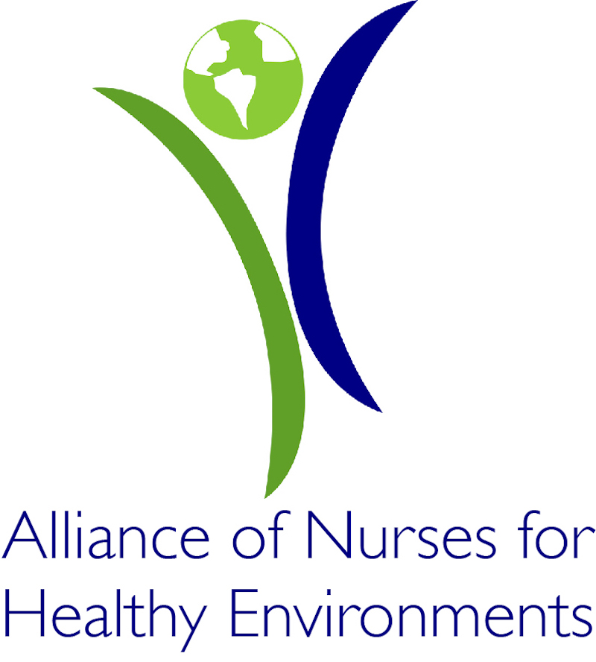**2017 ANHE California Environmental Health Workshop**

GREAT LEADERSHIP OPPORTUNITY FOR NURSES!

You are invited to the 2017 ANHE California Environmental Health Workshop where you’ll learn about the health impacts of environmental issues specific to California and meet with policymakers on how to protect the health of our patients and communities.

This unique opportunity will provide you with a chance to learn from nurse leaders and other

experts, connect with other like-minded nurses, gain great experiences that will enhance your

nurse leadership and provide you with tools you can use in your nursing practice and throughout your career, and make a real difference in protecting public health.

Nurses are the most trusted professionals and when you talk policymakers listen!

WHEN: February 25-27, 2017

WHERE: Sacramento, CA

COST: Free! Paid for by ANHE

Accommodations and meals are included

Travel scholarships available

We expect participants to be involved in at least two advocacy activities after the workshop, for

which ANHE will provide support and guidance. Examples include:

• Writing an op-ed or letter to the editor

• Meeting with your legislators or other policymakers

• Participating in a media event

• Writing a blog post

• Providing testimony

SPONSORED BY:

Alliance of Nurses for Healthy Environments

www.enviRN.org

WORKSHOP OBJECTIVES

* Develop a cadre of nursing leaders within nursing specialty organizations in California with the knowledge and skills to help identify and address environmental impacts on human health
* Provide tools to use in nursing practice to assess environmental exposures and provide patients/clients with anticipatory guidance to reduce health risks
* Discover where and how to find credible scientific sources regarding health effects associated with environmental risk factors, by using National Library of Medicine sources
* Cultivate your writing skills for Op Eds, Blogs, and other print and social media platforms for health messages
* Acquire skills and strategies for working with the media, including interviewing skills, promoting your message, and getting media placement for your stories, Op Ed columns, etc.
* Develop skills and strategies to educate policy makers and support policies and practices that promote healthy people and healthy environments

APPLY TODAY!

If you would like to attend please fill out this brief, online application by January 15, 2017

<https://goo.gl/forms/AOMZ3szHADI0pBe12>

WANT MORE INFORMATION?

Contact:

Erin Carrera, RN

[erin@envirn.org](mailto:erin@envirn.org)

415-548-0355