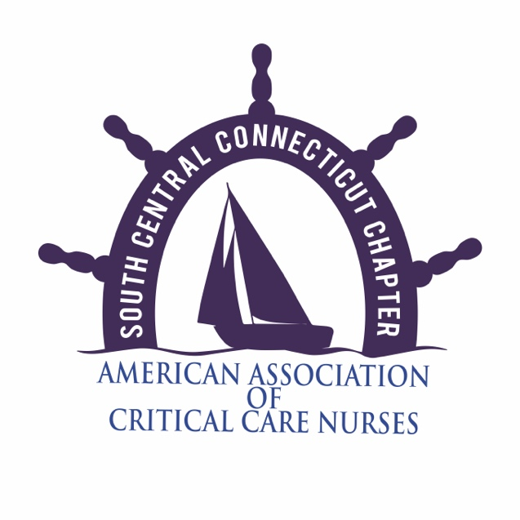

**Announcing a Call for Abstracts for It Matters! A Showcase of our Contributions the SCCC-AACN 4th Annual Evidence Based Practice Presentation Dinner**

Do you have an article being considered for publication?

Have you recently published an article?

Are you working on a thesis for graduate school?

Are you working on a hospital wide project to improve practice?

Are you part of a unit-based initiative?

Have you presented a poster or given a lecture at any hospital, local, regional, or national conferences this year?

If the answer is “yes” to any of the above, then we invite you to share your knowledge and experience with us at our annual January 2016 Dinner Lecture series where in the speakers are members of our own local critical care community and chapter.

This is an excellent opportunity to highlight your projects & outcomes, share new information or reinforce current practices, and to speak in front of an audience of your peers and colleagues. This evening has been so successful that we have decided to do it annually.

If you are interested in participating in this fun & exciting event and being one of our speakers, please submit a one page (approximately 500 words) abstract describing your project, your methods, your results, and how your project improves critical care nursing.

Please also submit your full name, credentials, place of employment, and contact information. Please send the abstract and your information to: Bethany Gleason at [looms104@gmail.com](mailto:looms104@gmail.com) or mail to 30 Laurel Glen Drive Shelton, CT 06484.

**Abstracts are due no later than December 10, 2016**

We look forward to seeing all the wonderful contributions our chapter members are making to critical care nursing and all the work they are putting into improving patient’s lives and clinical outcomes!!