|  |  |
| --- | --- |
|  | AORN Greater Houston #4407 Meeting Minutes  October 11, 2016 |

# Attendees

Members: 44  
Students: 32  
Visitors: 16  
Teleconference: 0  
Total: 92!

# Welcome – Nakeisha Archer - 1636

* Starting with “Who Wants to be a Millionaire?”
* This is fire prevention month! Be mindful of that!
* Need to start including a fire risk assessment in our time outs
* October is Breast Cancer Awareness month!
* Don’t forget to bring food or money next month! We will send reminder as well.
* TEXAS CHILDREN’S & NEXT MEETING
  + Move meeting starting next month.
* Check out our website and check out our Facebook page!
* THE POWER OF YOUR VOICE! *The Potential you have as perioperative nurses to advance your practice, our profession and AORN as an organization.*

# Who wants to be a Millionaire? – 1640 - 1651

## Team A – Michael - HBU student

* What is the primary means to protect health care personnel from occupational exposure to airborne contaminants generated by electro surgery?
  + C – local exhaust ventilation
  + AORN says: Local exhaust ventilation (LEV) is the primary means to protect health care personnel from occupational exposure to airborne contaminant generated by electrosurgery. Potential health and liability risks may be reduced by the evacuation of surgical smoke.
* According to ECRI institute, surgical fires occur most frequently:
  + B – on the patient
* An oxygen-enriched environment is defined as when the oxygen concentration is greater than what percentage by volume?
  + D – 21%
  + AORN says: An oxygen-enriched environment is when the oxygen concentration is greater than 21% by volume. In an oxygen-enriched environment, the temperature and energy required for fuels to ignite is lower than that of ambient or medical air.
* Which level of processing provides the highest level of assurance that surgical items are free of viable microbes?
  + C – Sterilization
* Which type of below is examples of active warming devices that help decrease the patient’s chance of experiencing unplanned hypothermia during the perioperative period?
  + B – forced air warming devices, circulating water garments, warmed IV fluids
  + AORN says: Cotton blankets, surgical drapes, and space blankets are examples of passive methods of warming the patient, not active methods. Find more about preventing perioperative hypothermia in your patients. Access the AORN Guideline for prevention of unplanned patient hypothermia and resources in the Prevention of Perioperative Hypothermia Tool Kit.

## Team B – Katy – HBU student

* Airborne contaminants that are produced during use of electro surgery include:
  + D – toxic gas & vapors, bio aerosols, dead and living cell material, including blood fragments; and viruses
  + AORN says: Analysis of the airborne contaminants produced during electro surgery have shown that electro surgery plume contains toxic gas and vapors (e.g. Benzene, hydrogen, cyanide, formaldehyde); bioaeorsols; dead and living cell material, including blood fragments; and viruses.
* The majority of fatal fires in OR are [blank] fires.
  + B – airway
* Active electrosurgical electrodes, lasers, and fiber optic light cords that are disconnected from the working element are considered [blank] in the fire triangle
  + D – none of the above 🡪 question stated DISCONNECTED
  + AORN says: Ignition sources (e.g. Active electrosurgical electrodes, lasers, electro cautery devices, fiber-optic light cords) should be used according to manufactures' instructions for use and AORN guidelines.
* Maintenance supervisor Joe is working on the ventilation system in the decontamination area of the sterile processing department. Joe verifies that all of the air is exhausted directly to the outdoors. What type of airflow system is this?
  + C – negative
* The top 3 sentinel events most frequently reported to the Joint Commission in 2015 were [blank]
  + B – unintended retention of a foreign body, wrong site surgery, and falls
  + JC says: 936 total sentinel events were reported to the Joint Commission in 2015 in this order (#1 being the most frequently reported):
  + Unintended retention of a foreign body
  + Wrong site surgery
  + Fall
  + Suicide
  + Delay in Treatment
  + Operative/postoperative complication
  + Other unanticipated event
  + Perinatal death/injury
  + Medication error
  + Fire
* TIE BREAKER: WHAT ARE THE RECOMMENDED TEMPERATURE RANGES FOR AN OPERATING ROOM?
  + D – between 68 degrees and 75 degrees
  + AORN says: The recommended temperature range in an operating room is between 68°F and 75°F. Collaborate with infection prevention, and facility engineers when determining temperature ranges. Each facility should determine acceptable ranges for temperature in accordance with regulatory and accrediting agencies.
  + **Resources:**
  + Guideline for a safe environment of care, part 2. In: Guidelines for Perioperative Practice. Denver, CO: AORN, Inc. *Updated March 3, 2015.*

# Business Meeting – 1652 - 1704

* Survey Results
  + How frequent do you feel chapter should meet?
    - Keeping the meetings monthly
  + Best time to meet?
    - We have now changed our time to 4 pm
  + Best way to receive communication?
    - Email. We have gone away from using OR nurse link. AORN national is still working on that and wants a solution for that.
  + Business meeting
    - 72% feel like it’s just right
  + Top two reasons for attending meetings?
    - Education of course. Networking.
  + Do not need to implement child care
  + Attend meetings offsite?
    - Most people said yes. This is something the board is looking into this year
  + Willing to help chapter in which ways?
    - We need to get more willingness to serve forms from everyone according to these results. Please let us know if you’re interested in helping.
  + Change location to TCH would this affect attendance?
    - 80% would not affect… some would come more often
* CHANGES WE MADE DUE TO SURVEY
  + Resurrect the website
  + Resurrect the newsletter
  + Year filled w edu and ceu’s
  + Added time for networking – changed time to 4pm for meet & greet
  + Communication by email – nursing network please verify your email on nursing network!
  + Change in meeting location 🡪 we will start meeting @ TCH next month – more info below
  + Information on committees for involvement 🡪 talked about last month and how to get involved … IF YOU WOULD LIKE TO BE INVOLVED IN A COMMITTEE PLEASE VISIT WEBSITE.
  + Nursing student outreach (8 memberships awarded) 🡪 commend everyone who donated money last month! We provided 8 student memberships! If anyone is willing to sponsor nursing students please let us know
  + Plans coming for more!
* Legislative report – Joanne Oliver – 1701
  + TODAY IS LAST DAY TO REGISTER TO VOTE!
  + Attended NLAC – conglomeration of many nursing organizations here. Look @ many issues coming to legislation. All info is on newsletter.
    - #1 mental health
    - #2 child welfare
    - #3 school finance
    - #4 border security
    - #5 public bathroom use
    - #6 campaign finance
    - #7 gun control
    - #8 voter ID
  + Significant Issues Related to Healthcare in Texas
    - Sunset of all Boards related to health (medical & nursing)
      * Means review of all policies and procedures as well as necessity to function as a board. Could include combination of some boards. Also determines budget requests.
      * Streamlining the nurse licensure compact/telehealth to further address the nursing workforce shortage.
      * They look at everything they’re doing to see if they’re going to refinance those boards
  + Granting “full practice authority” to all AP nurses without burdensome government restrictions and anti-competitive supervision by another profession. Requesting regulation of such be under board of nursing.
    - Includes nurse practitioners, clinical nurse specialists, certified nurse midwives & certified registered nurse anesthetists
  + Nursing shortage reduction program
    - Retention of the $33.75 million appropriation to work w/ TNA, texas universities and community college systems, as well as nursing educators. Currently 62% of nurses 54+ are eligible for retirements in 3 years
    - Continue growth of academic progression for all nurses, particularly RN to BSN programs and other higher education strategies
  + Safer working environments for nurses in mental health
    - Promote weapon free work environment already afforded to all licensed hospitals
    - Strengthen language in the mental health code that will facilitate civil commitment of individuals judged to be a danger to self or others
    - Explore ways to provide mental health services via telemonitoring, telenursing, and telehealth capabilities across all patient settings.
    - Fund programs that will reduce nursing shortage while increasing community based mental health services
  + If anyone is interested in helping Joanne and being on that committee visit website

# Education Session – Fredericka Acosta w/ Ethicon “Who are we and what do we do?” – 1715 - 1745

* What do you think of when you hear Ethicon? Suture, ligaclips, etc
* Johnson & Johnson medical devices – we thank YOU
* Recent change in how we can offer credits – can no longer just give out a CE for free. But can give out a website – you can download all three of courses and get 3 credits.
* HISTORY OF J&J
  + Ethicon products – suture 1887
    - 1944 – Ethilon 1st synthetic suture
    - ‘69 Prolene
    - ‘74 Vicryl
    - ‘98 Dermabond
    - 2003 Vicryl plus
    - 2005 Hernia solutions
    - 2010 Physiomesh
* J&J consists of 215 companies
  + Ethicon recently joined w/ Depuy
  + Ethicon product portfolio
    - Wound closure, trocars, endo mechanical energy, women’s health, hernia, biosurgery
* Ethicon – the beginning
  + ‘76 – Sen-Med was formed as a divison of Senco to design and manufacture mechanical surgical items
  + ‘84 – J&J acquired Sen Co
  + ‘86 – Ethicon built manufacturing in Ohio
  + ‘90 - first ENDOPATH trocar was brought to market
  + ‘92 – J&J spins off surgical instruments from Ethicon into a new operating company: Ethicon Endo Surgery – focuses on MIS because that’s the focus of today
  + ‘92 – establish separate company to focus on emerging endoscopic market
    - Develop a full line of endoscopic and mechanical stapling products
    - Develop key core competencies: surgeon edu, technology innovation, customer intimacy
* We are all over the world! Literally we need this internationalism to grow as a company. We have an institute in New Jersey and Cincinnati – this is another educational opportunity. There is a suture plant here in Texas as well
* ETHICON: SHAPING THE FUTURE OF SURGERY
  + - Help improve and save more lives
      * Assist and empower surgical teams to have a positive life changing impact on patients
      * Lend a hand for health and well being of our communities
    - Address pressing healthcare issues
    - Relentlessly pursue better outcomes
    - Advance innovation
  + We enable surgical potions that improve patient outcomes
    - Open surgery, MIS, next generation
  + Evolving market – why not be the leader in everything? Marker dynamics: aging pop, chronic disease, healthcare associated infection, increased regulation, health care reform, clinical economic evidence, borderless communication, emerging markets
* TAKE AIM PROGRAM – now available on ethiconinstitute.com
  + Target infection. Improve patient protection
    - The Ethicon Take Aim program is designed to help health care providers implement evidence based practices that address known risks for surgical site infections and blood stream infections through the appropriate utilization of Ethicon devices.
    - Click this link to view the full brochure: <http://www.ethicon.com/sites/default/files/managed-documents/020572-160202_take_aim_one_pager_0.pdf>
    - <http://ethiconinstitute.com/>
* ETHICON INSTITUTE & CEU
  + <http://ethiconinstitute.com/continuing-education>
  + Ethiconinstitute.com 🡪 infection education 🡪 several videos you have to show your team/staff
  + Video of BASIC INFECTION ISSUES
* Sustainability issues – company called sterile med – part of j&j family. Ethicon works in partnership w them. No automatic enrollment – depends on how the hospital wants to proceed. Up to hospital if they want to subscribe to them or not. Can have a presentation w/ the hospital to see if they want to have this in the facility

# Announcements & Events

* AORN nurse executive leadership seminar - <https://www.aorn.org/events/nurse-executive-leadership-seminar>
* HOUSTON FOOD BANK AORN OF GREATER HOUSTON FOOD DRIVE
  + Taking donations this meeting and next meeting
  + Working at TCH? Nakeisha Archer will take donations!
  + Can also donate through paypal on the website! 🡪 <https://aornhouston.nursingnetwork.com/page/42951-food-drive-donations>
* Medical bridges volunteer dates – 9a to 12
  + Oct 22
  + Nov 12
  + Dec 3
  + 2706 Magnet Street Houston, TX 77054
  + Questions: Email [darlenemurdock@hotmail.com](mailto:darlenemurdock@hotmail.com) for more information
* CNOR Prep course 10/22-23 – 16.0 CE
* TEXAS AORN guideline implementation workshop - Nov 5th
* AORN chapter West Houston #4436 – 3rd annual perioperative patient safety seminar
* AORN AMBASSADOR PROGRAM -
* 

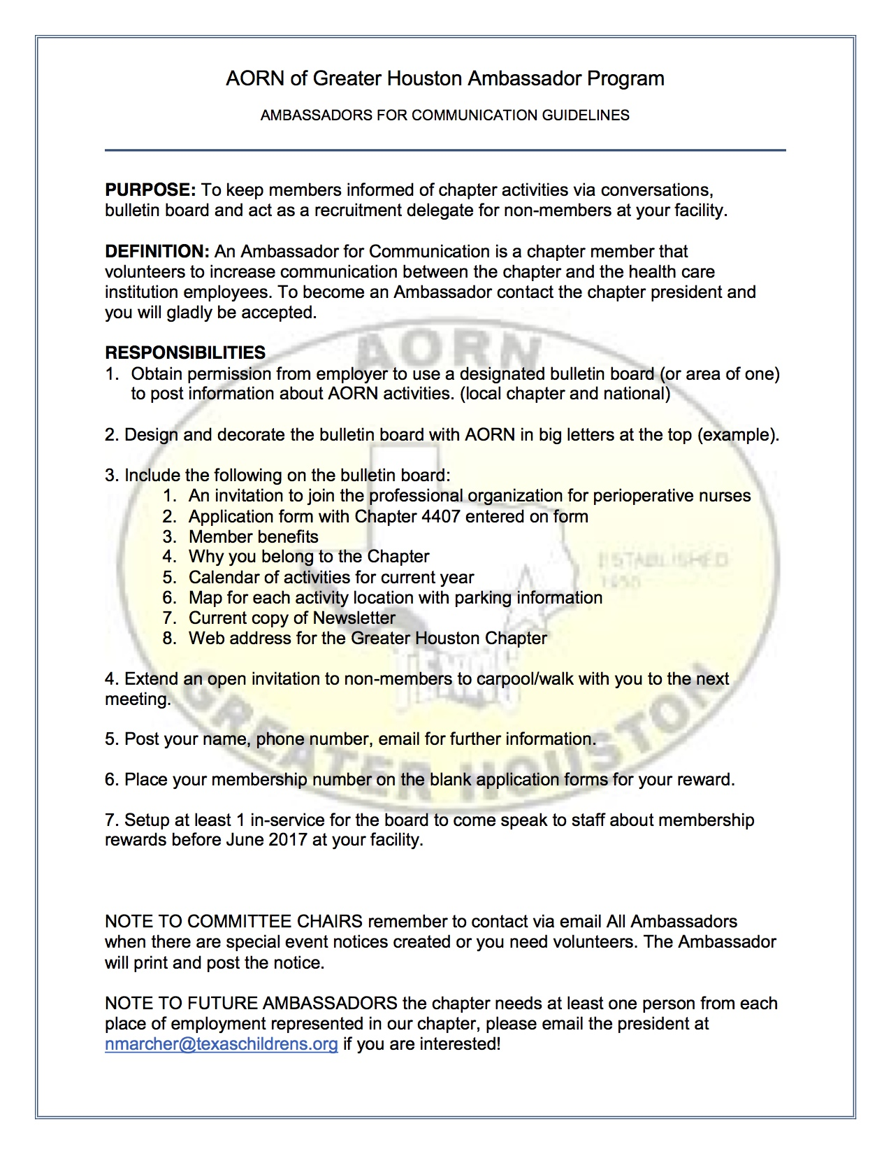

* THINGS TO LOOK FORWARD TO:
* December: holiday celebration and toys for tots event – need operation game or nurse dolls/toys, anything medical, toys for tots drive, want to give back to kids on a unit, during December bring the toys, can’t make that but want to donate you definitely can.
* Leadership symposium – more to come – interested in being on the planning committee

# Next meeting

November 11, 2016 ~ 4pm ~ Pavilion for Women @ TX Children’s Hospital

* Next month: celebrate periop nurses week, fun things for students

Agenda:

Meet & greet 4-4:30

Around the horn 4:30 – 5

Business 5-530

Education 5:30-6:30

Location: Texas Children’s Hospital Pavilion for Women 4th floor conference center rooms D & E 6651 Main Street Houston, TX 77030

Teleconference information: call in number: 832-824-0000 / collaboration code is 123439#