

**Diamond State Chapter Members Matter!**

**WHY I BECAME A CRITICAL CARE NURSE**

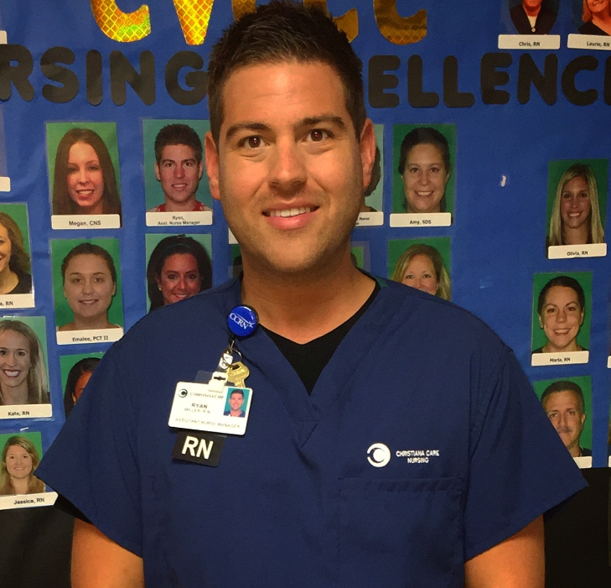I decided to become a Registered Nurse following a close family member’s illness and hospital stay while I was in High School. I was overwhelmed seeing nurses’ unending caring compassion for my lived one and I was determined to make a difference in patient’s lives. I obtained by BSN from the University of Delaware in 2010 and have worked for Christiana Care for over 6 years. I began my career with Christiana Care while I was in nursing school. I have worked as a student nurse extern, safety companion, Registered Nurse and now Assistant Nurse Manager of the Cardiovascular Critical Care Complex. Deciding to accept the position in the Cardiovascular Critical Care Complex after a 6 month internship was one the best decisions of my life. I was encouraged by a close mentor from nursing school to take the position. I am forever grateful to her for the encouragement, because I love what I get to do every day. I am so grateful to my peers and mentors within my unit who continue to challenge and encourage me to be a better nurse. Having the privilege to learn from my peers has been the most valuable to me in my nursing career. The incredible teamwork, education, collaboration and mentorship within my unit are exceptional. I am so passionate about nursing and fortunate to work in the Cardiovascular Critical Care Complex at Christiana Care. I am proud to be a critical care nurse.

**Ryan Miller, BSN,RN,CCRN**