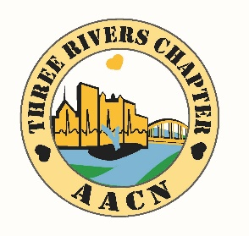***Three Rivers Chapter of***

***American Association of Critical Care Nurses***

***Kickoff to the 2016-17 Program Year!***

***Membership, Mentoring and Engaging: Benefits of Becoming an AACN Member***

***Wednesday August 31st, 2016***

6:00 PM – 9:00 PM

Dave & Buster’s

180 E Waterfront Drive

Homestead PA, 15120

Spend an evening with the TRC Board! Learn about benefits of belonging to a professional organization, network with new friends and old, and enjoy some refreshments.

This session will also focus on introducing our professionals of the future to the Chapter!

(Buffet dinner and a $10.00 Gaming ticket are included with registration! Alcoholic beverages are not included in cost of session.)

Come meet Our Region 3 Chapter Advisor!

Charlene Trimeloni, MSN, RN, CCRN, PCCN will be presenting:

Volunteering for AACN: “It Matters” at the Bedside

This program has been approved for 1.25 contact hours Synergy CERP Category C.

The assigned program number is 00019815.

***Registration Deadline:*** **Thursday, August 25th, 2016**

**TRC AACN reserves the right to cancel 5 days prior to event if minimal registration is not met. Those registered will be notified via e-mail and all funds returned. No refunds once payment is received for no-shows.

Speakers and topics subject to change based on availability.

**Cost:** $ 18.50 for Chapter Members

$ 28.50 for Non-Chapter Members (including expired TRC memberships)

Student Nurses free with proof of School program attendance!!

***Please register at our new Website! <https://traacn.nursingnetwork.com>

For information or questions, contact Wendy Grbach at [grbachwen@msn.com](mailto:grbachwen@msn.com)



\**TRC AACN would like to ask attendees to wear their employer ID badge for ease of networking*!