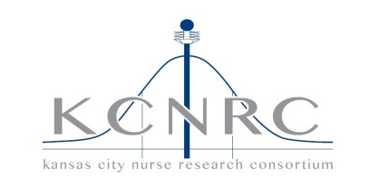

Friday 8/19/16

7:30-9:00am

Saint Luke’s Health System Corporate Office (8th floor)

901 E. 104th St

KCMO 64134

Contact person: Jacque
Carpenter (816-502-8560)

Dial in Number: 1-866-374-2894
Conference Code: 3585519509

- Introductions and changes to agenda
- Minutes 6/17/16 (email vote: approved –7; approved with revisions –0; abstained –2).
- Clinical Research Presentation:
- Announcements
  - Hospital Education Programs
  - Clinical Trials/Research Studies
- Old Business
  - Website: nursingnetwork.com – M Fox
  - Career Expectations Study – S Klaus
  - Nurse Executive update – M Fox
  - 2016 KCNRC Symposium review—J Carpenter
- New Business

- 2016-2017 meeting locations- C Glennon 10/21/16 (follow STTI?) 1/20/17 SJMC Not confirmed: 3/17/17 and 6/16/17
  - Next meeting: 10/21/16 (follow STTI?)
- Adjournment

AGENDA

Kansas City Nursing Research Consortium

