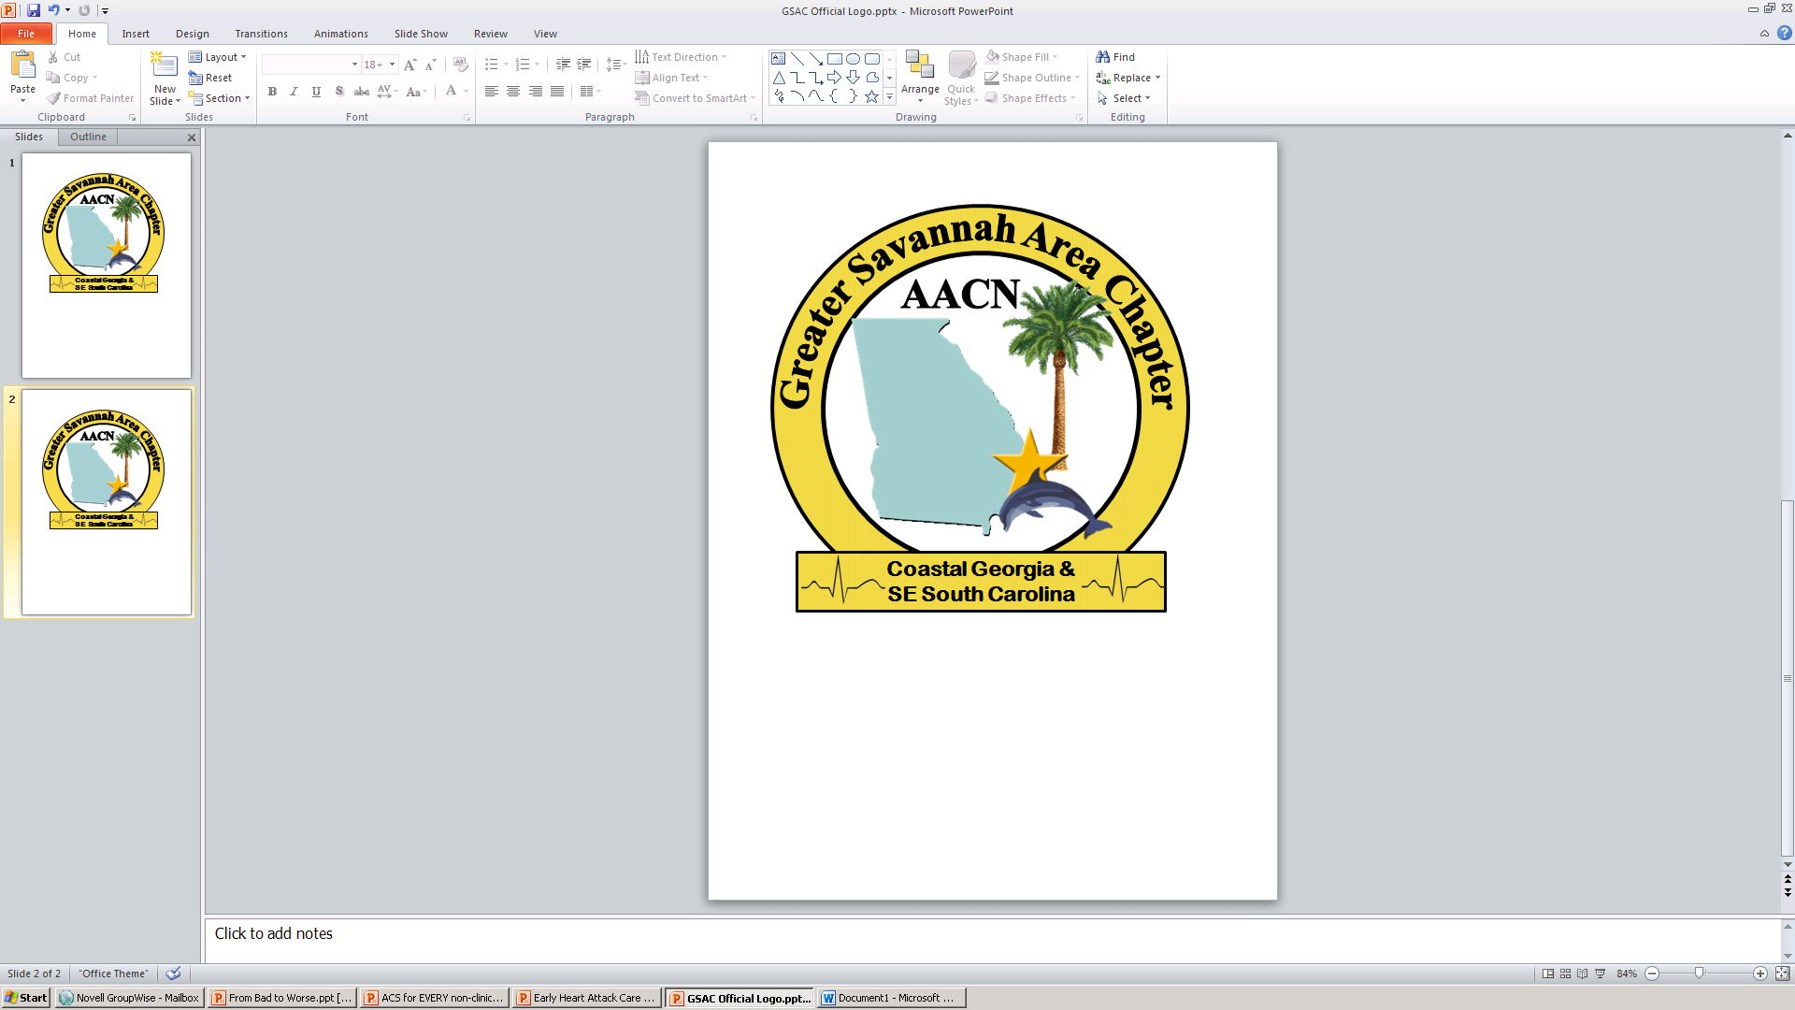

**2016 CCRN REVIEW COURSES**

**SPONSORED BY GREATER SAVANNAH AREA CHAPTER**

**Adult CCRN/PCCN Review Course Pediatric CCRN Review Course**

**October 26 , 27 2016 November 3 ,4 2016**

These review courses will be presented in webinar fashion with a topic expert present to facilitate post presentation discussion and review of topic specific practice test questions. With each topic you will receive handouts of the slides for note taking, as well as practice exam booklet from AACN.

Location: Education Building, Memorial University Medical Center, Savannah Ga.

Registration: includes handouts from presentations, practice exam, and snacks

General - $125.00

***Cancellation must be in writing via email listed on registration form. Cancellation fee of $25 will apply up to 14 days prior to course. Cancellations received within 14 days of course will not be refunded.***

AACN national member - $100.00

GSAC member - $80.00

Lunch each day is on your own.

Overnight accommodation information if needed will be mailed with your confirmation of registration

You are encouraged to review additional learning resources listed at www.AACN.org

To print out registration form: <https://gsacaacn.nursingnetwork.com>