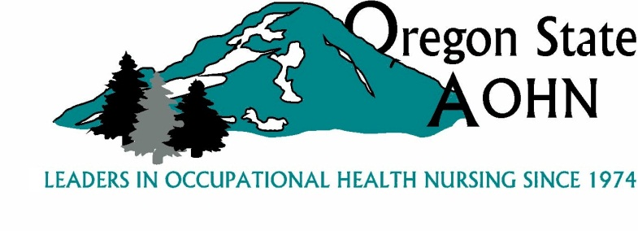

**2018 Winter Business Meeting and Holiday Gathering OSAOHN**

**Legacy Woodburn Health Center--**

**1475 Mt. Hood Avenue**

**Woodburn, OR 97071**

**AGENDA**

**Friday November 30, 2018**

11:00 – 12:00 Guest Speaker – Assessing Injury in the Aging Workforce

12:00 – 1:00 Lunch/Ornament exchange

1:00 – 1:05 Business Meeting Call to order and opening remarks - Marlin Kendall

* Approval of Minutes of the last meeting

1:05 – 1:15Treasurers Report and Review of Budget Proposal - Chris

1:15 – 1:45 Committee Reports

1:45 – 2:00 GOSH and OSAOHN continuing education partnership update - Linda and Marlin

2:00 PM Adjourn

Ornament exchange to be conducted during lunch - $10 limit if you plan to participate