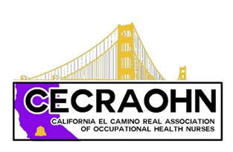 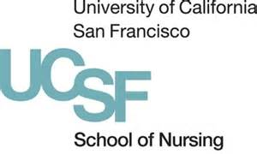 

**CECRAOHN-UCSF Continuing Education Program-Plan now to join us!**

**Clinical and Research Updates in Occupational Health**

**Come hear the latest on the Zika virus from an UCSF Global Health expert, enjoy a conversation with Frances Childre of Premise Health, view posters from UCSF faculty on their programs of research, and learn what students are doing in evidence-based program planning in local industry.**

**Friday, June 3, 2016, 7:45AM-12Noon**

**Location: UCSF Library, 2nd floor, CL221/222, Parnassus Campus**

7:45AM-12Noon (4 contact hours)

7:45-8:25AM Registration and Breakfast

8:25-8:30AM Welcome OiSaeng Hong, RN, PhD, FAAN, FAAOHN, UCSF OEHN Program Director

8:30-9:30AM Update on Zika Virus George Rutherford, MD, MPH, Director of the UCSF Institute for Global Health

9:30-10:10AM Vendor Relationships—What does the future hold? Frances Childre, MSN, RN, COHN-S, FAAOHN, Associate VP, Operations, Premise Health and UCSF OEHN Alumnus

10:10-10:30 Break/ Poster viewing:

Research on CV Risk Factors of Taxi Drivers, Barbara J. Burgel, RN, PhD, FAAN, FAAOHN

Associations of organizational safety practices with workers’ perceptions and safety behaviors, Soo Jeong Lee, RN, PhD

and musculoskeletal symptoms among hospital nurses

Factors associated with safe patient handling behaviors and lift use among hospital nurses: Soo Jeong Lee, RN, PhD

A statewide survey of California nurses

CV Risk Factors of Firefighters Dana Drew Nord, RN, PhD

Hearing hazard associated with occupational noise exposure among firefighters. OiSaeng Hong, RN, PHD, FAAN, FAAOHN

We drive in big red trucks and make lots of noise: Noise exposure and hearing protection in firemen. OiSaeng Hong, RN, PHD, FAAN, FAAOHN

10:30-11:50 OEHN MS Student Presentations

11:50-12:00 Closure/Evaluation

Lunch on your own.

Register now at www.cecraohn.org

Send checks to Barbara Burgel, UCSF School of Nursing, 2 Koret Way, N505Y, San Francisco, CA. 94143-0608 **no later than June 1, 2016**

Costs:

Non-member: $20.00

AAOHN/CSAOHN/CECRAOHN Member: $10.00

Students (no CE units): Free (must be registered no later than May 26, 2016)

Approved for California Board of Registered Nursing, CEP #6919.