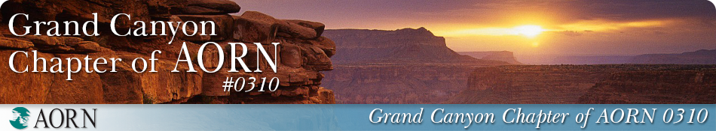

CNOR Scholarship Application

To qualify for this CNOR Scholarship, please verify active participation in AORN within the last year. This scholarship award will be $335.00 (for 1st time and recertification by exam applicants) or $285.00 (for recertification by points or contact hours. Please attach receipt of payment for certification as well as passing result or proof of recertification.

Requirements for Applicant

NAME: DATE:

ADDRESS:

EMAIL ADDRESS:

EMPLOYER:

POSITION:

CHAPTER ACTIVITIES:

OFFICES HELD:

C0MMITTEES- CHAIR/MEMBER:

NUMBER OF MEETINGS ATTENDED THIS YEAR:

On a separate word or PDF document, please answer the following questions:

* If you attended less than six chapter meetings, please explain.
* In a statement of one hundred words or less, please express your goals for becoming a CNOR:
* In less than 100 words, please describe the value of certification.

The Scholarship Committee of Grand Canyon Chapter of AORN will review all completed applications on a rolling basis. The scholarship will be announced via Nursing Network and presented to the selected recipient(s) during the subsequent AORN business meeting**.** Those not selected will be notified by email.

Email completed applications with accompanying Word or PDF attachments to:

Cambria.Nwosu@gmail.com