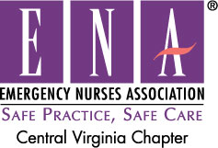

Please join us for our Central Virginia ENA meeting
Bon Secours Virginia
Memorial Regional Medical Center
Main Conference Room (next to Cafeteria)
8260 Atlee Road
Mechanicsville, Virginia 23111
on Thursday
December 10, 2015
1730hrs - 1930hrs
Dinner Presentation: Rapivab by BioCSL
Gift Exchange (Gift $20.00 and under)

Must RSVP to Terecia Vermeer at tmvermeeredrn@gmail.com, Central VA ENA website, or Facebook by Friday, December 4, 2015 in order to have accurate head count for dinner


