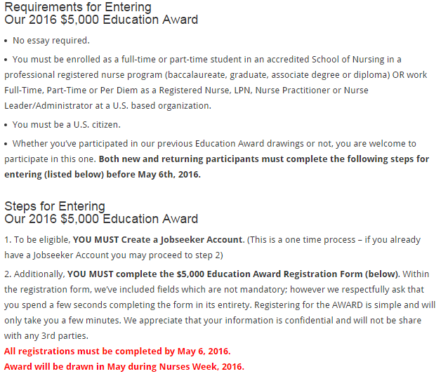

Register on line at:

<http://diversitynursing.com/education-award-registration-2016-mobile/>