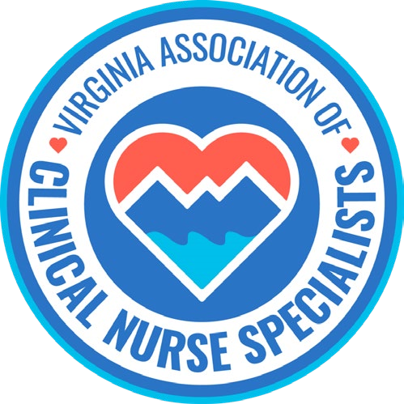
Our Mission:
Promote the role of the clinical nurse specialist as an advanced practice registered nurse in Virginia, and improve systems of care, prevent disease, and enhance health
and well-being through evidence-based population care.
MEMBERSHIP MEETING AGENDA
Nov 9th, 2026 6:00 pm to 7:00 pm
Zoom Meeting: https://us02web.zoom.us/j/611829893?pwd=Tkl1aWJOY0JhelVkMUlUaFpkK0MrZz09
Phone number 1-929-205-6099; Meeting ID: 611 829 893 Passcode: 329587
Discussion Items | Facilitator
Welcome & Announcements  Introductions of new members /Guests  Member Achievements | Sarah Taylor & Members
Minutes  Approval of Minutes | Ellen Harvey/Members
Reports  - Treasurer  - Social Media | Sarra Wildermuth  Cindy Ward
Standing Committees  - Finance  - Program Planning  - Growth & Succession  - VaCNS Elections  - Legislative/Regulatory  - NACNS Leg/Reg Updates | Holly Tanaglia  Stacia Landrom  Amy Lucas  Erin Smith
Open Discussion  - Future Topics of Discussion  - Guest Speakers | Phyllis Whitehead :  Palliative Care to NACNS President  President”
Old Business | - 2027 conference (April 23-24,2027)  - Lobbyist search
New Business
Adjourned  Next meeting | Dec 14th @ 6: PM  At 6:00

