AORN RNSA |  |  | October 2026
Retired Nurses Special Assembly Newsletter
By and for AORN nurses

Please note our group name. We are made up of retired nurses but also include those of you that are taking a break from work for various reasons. As older retired nurses, we offer ourselves as educators, sharers of our years of knowledge and experience. All we need is for someone to ASK, and you will be surprised at what you learn.



October 22, 2026: 8 PM Eastern, 7 PM Central, 6 PM Mountain, 5 PM Pacific.

RNSA scheduled Zoom meeting, link will be posted and should turn up in your email. If not, let us know.

https://aornretired.nursingnetwork.com/
This is the link to our new homepage. If you have not signed into the AORN main page, you will probably need to do that to access the nursing network site, which will require another sign-in. Once you have found a group, you have dropdowns on the left that you can explore. Announcements for upcoming meetings or events may be on the front page for the group. Check out the space and explore. Let us know if you have any questions. We’ll help!!
Mission & Vision
The Retired Nurses Specialty Assembly is for perioperative nurses who are retired, in transition toward retirement in their careers, or interested in tapping into the expertise of perioperative nurses with a vast array of experience in a variety of specialties.
· Provide a forum for networking for retired nurses and other members interested in learning about the Retired Nurse SA
· Increase communication and collaboration among nurses who have similar work functions.
· Serve as a resource for AORN in all areas of perioperative nursing.
· Serve as a resource for the membership of AORN on matters concerning retirement.

If you are interested in joining us, or to visit, we can be found by going to:
https://aornretired.nursingnetwork.com

Member Spotlight
The dearly departed AORN retired nurses


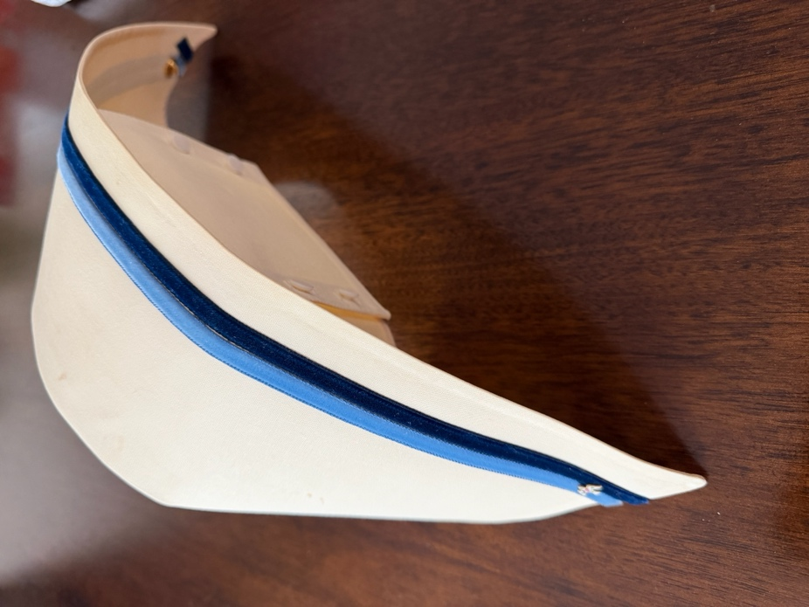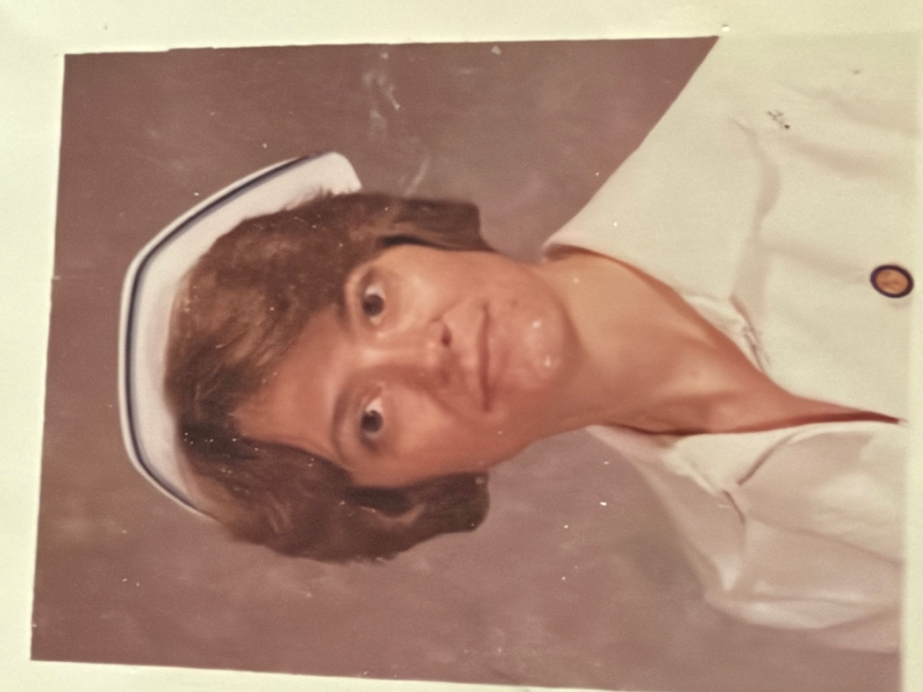

Before nursing had scanners, screens, and endless digital documentation, there were nurses who walked through hospital doors dressed in white and carried an incredible amount of responsibility with them.  Their uniforms were neatly pressed. Their shoes were kept spotless. And that little nursing cap wasn't simply part of the outfit—it meant something. Mine was from Lima Technological College (LTC), Lima, Ohio, 1982-1983. I took an accelerated ADN degree over 18 months. Once we reached halfway, we put one blue strip on (the light blue). At graduation, the final dark blue. I had dreamed of this type of cap exactly and was surprised when I enrolled to find this was the one I would wear until dress codes changed.

For many nurses, earning that cap marked the end of years of training and the beginning of a profession built on discipline, knowledge, and service. Those nurses practiced in a very different world. Patient information lived on paper. Blood pressures were taken by hand.
There were no electronic alerts reminding you what to check next. You learned to recognize subtle changes by watching closely, listening carefully, and knowing your patients—not by waiting for a screen to tell you something was wrong. And there was always someone more experienced nearby. A senior nurse who could teach you, correct you, encourage you, or give you that look when you clearly needed to think twice. 
The work was demanding. Long shifts. Difficult situations. Emergencies. Loss. Exhaustion. And somehow, nurses still found ways to laugh, support one another, and keep going. Then healthcare changed. The white uniforms became memories. The caps were tucked away in drawers and keepsake boxes. Paper records gave way to electronic charts. Technology transformed nearly every part of the job. But today's nursing stands on the foundation built by those who came before. They passed down clinical knowledge, professional standards, traditions, compassion, resilience, and the lessons learned through countless difficult shifts. The uniforms may have changed. The technology certainly did. But the legacy of those nurses is still present every time a nurse walks into a patient's room and cares for someone who needs them. Some eras disappear. The impact they left behind doesn't.

Food FOOOD FOOOD YUMMY FOOD

Mediterranean Cookies
Yield: 60 Cookies
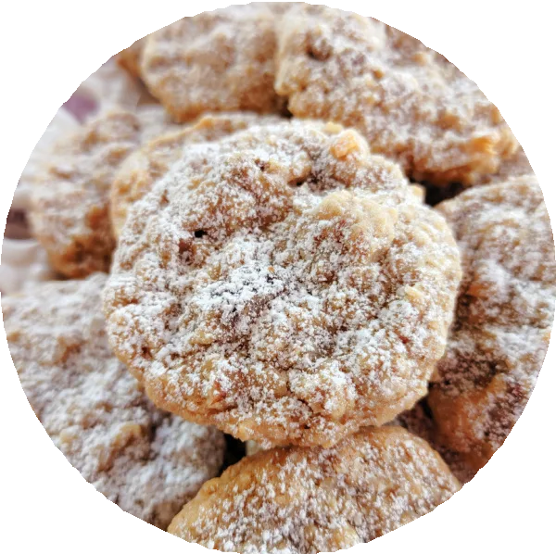

Chewy, chunky oatmeal cookies with coconut, walnuts, dates and one unexpected ingredient that adds a subtle, uniquely Mediterranean ﬂavor.

INGREDIENTS/PREPARATION
Cream butter and sugars with an electric mixer (paddle attachment if using a stand mixer) until smooth on medium-low speed.
1 cup butter, room temperature
1 cup dark brown sugar, packed
1 cup white sugar
Add vanilla, olive oil and eggs then continue mixing until well combined.
1 tablespoon vanilla extract
1 tablespoon extra-virgin olive oil
2 eggs
In a separate bowl, stir together ﬂour, salt, baking soda, baking powder and oats.
2 cups ﬂour
1.5 teaspoons salt
1 teaspoon baking soda
1 teaspoon baking powder
2 cups rolled oats
With mixer on low speed, add ﬂour mixture to wet ingredients then mix until just combined.

Add walnuts, coconut and dates then continue mixing until well incorporated.
1 cup chopped walnuts
1 cup sweetened ﬂaked coconut
8 oz pitted dates, diced
Refrigerate dough at least 10 minutes.

Meanwhile, preheat oven to 350 degrees. Using a cookie scoop or 2 spoons, portion out dough then place on an ungreased cookie sheet 2 inches apart. Bake 10 minutes or until the edges are starting to brown at the bottom. Rest cookies on the hot pan 5 minutes then remove and dust with powdered sugar.
¼ cup powdered sugar

NOTES:
The olive oil adds a subtle, uniquely Mediterranean ﬂavor. If you don't have any, just omit the oil (no need to add another type of oil). Light brown sugar can also be used. These don't spread too much so I am able to ﬁt 15 cookies on a standard-sized baking tray. I cook two pans at once using convection mode and rotate the pans halfway through cooking. I use quick-cooking oats but old-fashioned can be used as well.
Pecans, pistachios or macadamia nuts can be substituted for the walnuts.
8 ounces of pitted dates yields about 1.75 cups of diced dates. Raisins or dried cranberries can be substituted for the dates. Use a small mesh strainer to dust the powdered sugar on for even distribution. I actually use 2 teaspoons of salt in these (plus salted butter) and think it's perfect, but the dough walks a ﬁne line between just right and a skosh salty, so I wrote the recipe for 1.5 teaspoon

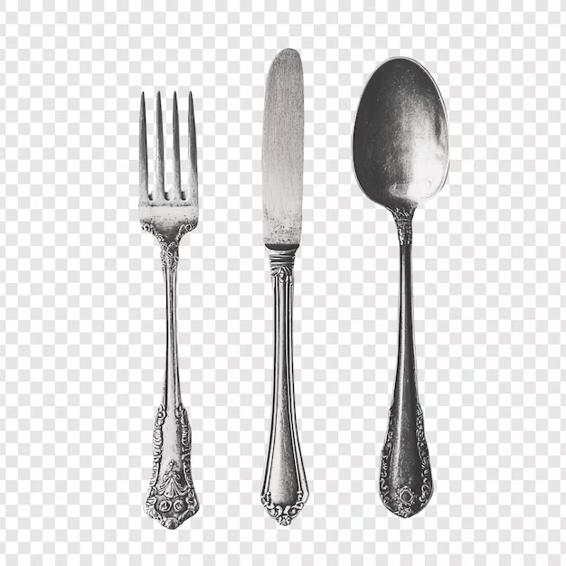
WHAT IS THIS? WILL BECOME A CONTINUED FEATURE.
So, if you have a strange something that you would like to share, send to Pam (me) and I’ll add to the newsletter.

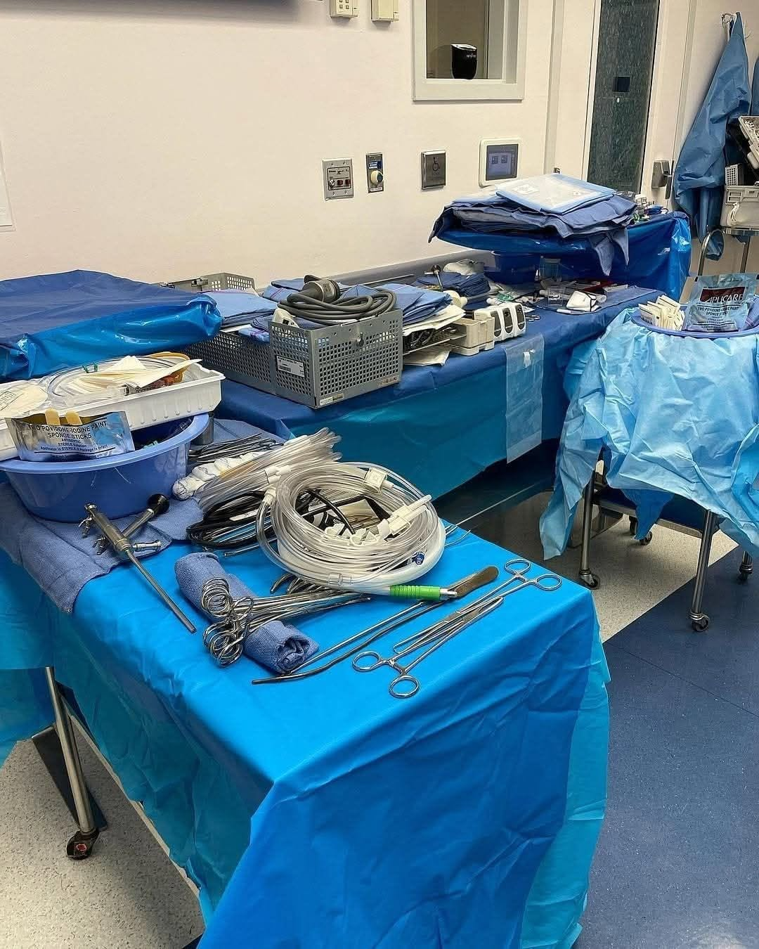

Study this image. And then ask yourself (provided you notice something wrong), would you want this person operating on you or a family member? How many issues do you see? There may be none, or a ton, just depends on what you may look for.

""""""""""""""""

Comments and/or RNSA Newsletter materials, suggestions, etc., are welcome and may be sent to:
Pamayla Darbyshire usafrnped@yahoo.com
Thank you to all contributors.

RNSA Council:
Chair: Cheryl Sumner, RN, CNOR (e) (OH)
Past Chair: Cathy Ostroski, DNP, RN, CENP (NJ)
Chair-Elect: Cheryl Sumner, RN, CNOR (e) (OH)
RNSA Mentor: Joanne D. Oliver-Coleman, MBA-HM, BSN, RN, CNOR (e) (TX)
Board Liaison: David Reinhart, DNP, MBA, RN, CNOR, FAAN
Communications Chair: Patricia Moody, RN, CNOR (e) (IN)
Communications Chair-Elect: Patricia Moody, RN, CNOR (e) (IN)
Education Chair: Melanie Burton, BSN, RN, CNOR, MLSO (WA)
Education Chair-Elect: Melanie Burton, BSN, RN, CNOR, MLSO (WA)
Newsletter: Pamayla E. Darbyshire, DHA, MSN/CNS (UT)

For those that like to read or listen to audiobooks:

Libby App: Free ebooks & audiobooks from your library

OverDrive https://www.overdrive.com
You can Access thousands of free ebooks & audiobooks online with Libby, the library reading app by OverDrive. Enjoy free reading & listening on any device.

