(Tau Chi Chapter,Inc.)
Chi Eta Phi Sorority, Inc.®
(Eta Pi Chapter)
Omega Psi Phi Fraternity, Inc.
American Red Cross Community Blood Drive
Omega Family Resource & Learning Center
132 South Harrison Street
East Orange, NJ 07018
Saturday December 12, 2026
9:00am-2:00pm
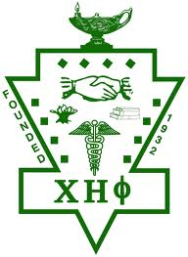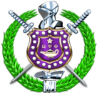
Call 1-800-RED CROSS (1-800-733-2767) or visit RedCrossBlood.org and enter: EastOrangeCommunity to schedule an appointment today.

Blood donors who are Black play a critical role in helping patients battling sickle cell disease receive the most compatible blood match. Today, there aren’t enough blood donors to meet this urgent need and ensure those fighting sickle cell disease have continued access to the treatments they need.


