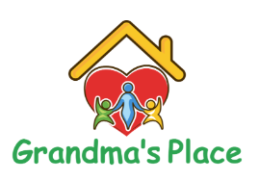
“We Nurture, Love & Help Abused and Neglected Children and Families of Children with Disabilities” www.grandmasplacepb.org
- Paper cups (small and regular size), paper plates, and paper bowls
- Cases of bottled water
- Ice pops
- Apple juice (large bottles) and juice boxes
- Iced tea, lemonade, or Gatorade mix/powder
- Individual snack packages (chips, cheese puffs, etc.)
- Laundry detergent (liquid or powder)
- White towels and washcloths (child size)
- Gallon-size Ziploc bags and plastic wrap (commercial use)
- Socks for girls and boys, sizes 2–14
- Plastic storage containers (70 Qt/66L or 64 Qt/61L)
- Garbage bags (30 lb and 13 lb)
- Windex
- Clorox wipes
- Lysol spray
- Batteries (AA, AAA, C)
- Dishwasher pods or powder
- Disposable gloves
- Hand sanitizer
- Hair brushes and girls’ hair products
- Child Toiletries; Diaper rash cream (Balmex or Desitin), Neosporin, and Aveeno soothing bath treatment
*Amazon requested supplies listed on the website too

