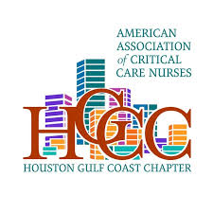
AACN Houston Gulf Coast Chapter Invites You To an Educational Chapter Meeting

Where: Simone on Sunset
2418 Sunset Blvd
Houston, TX, 77005

Topic: Fecal Incontinence Automation
Sponsor: Consure Medical
Speaker: Michael Bierman, Territory Manager

When: September 25, 2026
Registration begins at 6:30pm, presentation at 7pm
Register on Nursing Network
Seats are limited, so sign up soon to secure your spot!

