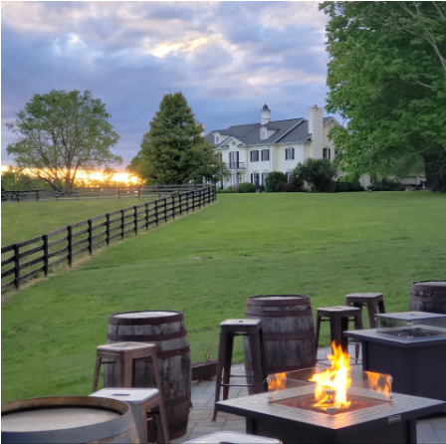  - LET’S GET SOCIAL  inverness Brewing  AORN of Baltimore Chapter 2101  Invites you to join us for an afternoon of relaxation and networking in the heart of Maryland’s horse country. We have reserved the lower level of the main barn for this event.  Inverness offers a family-friendly atmosphere, serving their custom beers, as well as non-alcoholic options. They have a food truck with an extensive menu.  Outside food and beverages are not permitted  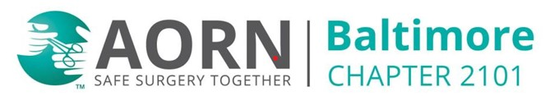
  Saturday, October 10, 2026
  Noon to 4 pm
  ____
  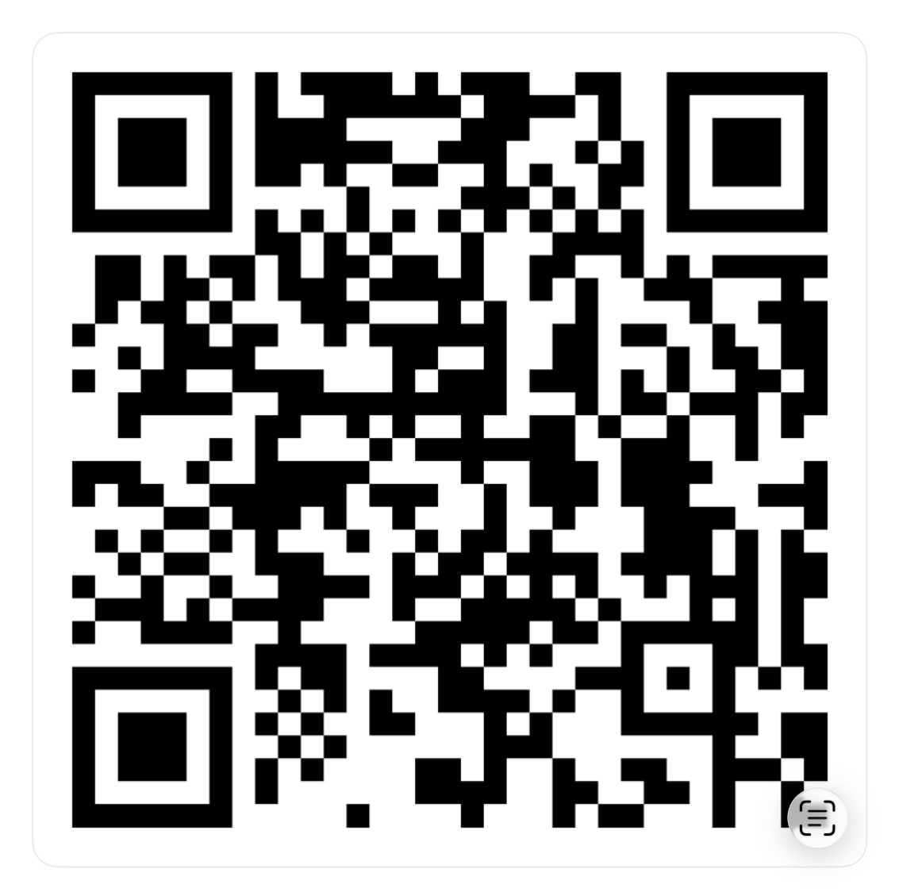
  Please RSVP
  ____
  RSVP LINK
  Inverness Brewing
  16200 Markoe Rd
  Monkton, MD 21111
  443-829-2142
  https://invernessbrewing.com

