
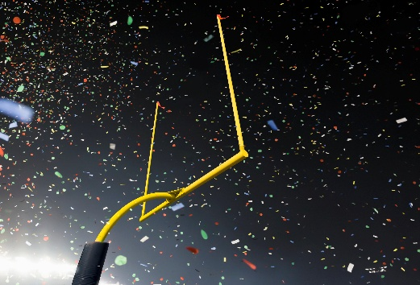 AORN’S FALL KICK-OFF
MEETING
PLEASE JOIN US AT:
Rascals Bar & Grill, 5223 Torque Rd. Loves Park, IL
September 2, 2026 @4:30 PM

(Meet on the patio-weather permitting)

