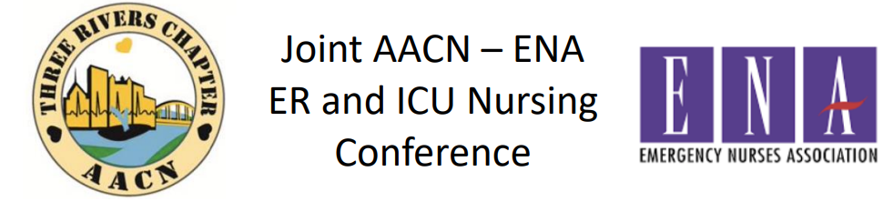
Elevate Acute Emergency and Critical Care Nursing
When: October 30,2026
Where: RLA Learning and Conference Center
850 Cranberry Woods Dr, Cranberry Twp, PA 16066
Registration: Online ONLY
https://traacn.nursingnetwork.com/ OR 

Cost: TRC-AACN/ENA Members: $90; Non-Members to either organization: $105, Student: $50
Time | Topic | Speaker
7AM-7:45AM | Registration, Breakfast | Virtual Poster Presentations-repeating
7:45AM-8AM | Welcome, Introduction | Wendy Grbach, Three Rivers AACN President  Lorna Woodhall, Emergency Nurses Western PA Chapter President
8AM-9AM | Chest X-Ray Interpretation Made Easy | Denise Ramponi, DNP, FNP-C, ENP-BC, FAANP, FAEN
9AM-9:30AM | Break | Take time to visit vendors
9:30AM-10:30AM | Toxicology Updates: What’s the Buzz? | Anthony Pizon, MD  Chief, Division of Medical Toxicology, UPMC
10:30AM-11:30AM | Elderly and Delirium Management | Morgan Mihok, MD  Geriatrician, Allegheny Health Network
11:30A-12:30P | Lunch | Take time to visit the vendors
12:30PM-1:30PM | I’m Not Throwing Away My Shot: Re-emerging Childhood Infectious Diseases | Kelly Bedner, MSNEd, BSN, RN, CEN  Emergency Dept Nurse Educator,  WVU Medicine-Westmoreland
1:30PM-2PM | Break | Take Time to visit vendors
2PM-3PM | A Vampire’s Guide to Anticoagulant Medications | David Pavlik, Pharm D  Clinical Specialist  AHN-Wexford Hospital
3PM-4P | From Bellyache to Battlefield: Triaging and Resuscitating GI Emergences | Ellen Tan, DO  PGY-6 Gastroenterology, Hepatology and Nutrition Fellow  AHN-Allegheny General Hospital
4PM | Wrap up and evaluation | *CE credit provided at completion of event with evaluation return
This activity has been submitted to the American Association of Critical-Care Nurses for approval to award contact hours. The American Association of Critical-Care Nurses is accredited as an approver of nursing continuing professional development by the American Nurses Credentialing Center’s Commission on Accreditation.

