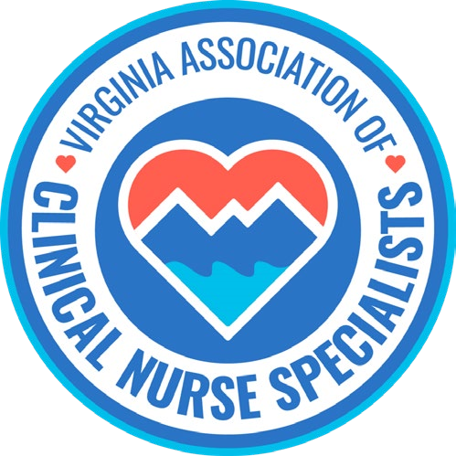
Our Mission:
Promote the role of the clinical nurse specialist as an advanced practice registered nurse in Virginia, and improve systems of care, prevent disease, and enhance health
and well-being through evidence-based population care.
MEMBERSHIP MEETING AGENDA
August 10th, 2026 6:00 pm to 7:00 pm
Zoom Meeting: https://us02web.zoom.us/j/611829893?pwd=Tkl1aWJOY0JhelVkMUlUaFpkK0MrZz09
Phone number 1-929-205-6099; Meeting ID: 611 829 893 Passcode: 329587
Discussion Items | Facilitator
Welcome & Announcements  - Introductions  - Member achievements | Sarah Taylor/Members
Minutes  • Approval of minutes | Ellen Harvey
Reports  - Treasurer  - Social Media  - Standing Committees  - Finance  - Program Planning  - Growth & Succession  ● Volunteer Forms  - Legislative/Regulatory  - NACNS Leg/Reg Updates  ▪ Open discussion  - Future topics of discussion  - Guest speakers | Sarra Wildermuth Cindy Ward  Holly Tenaglia  Stacia Landrom & Trina Carter  Amy Lucas  Erin Smith  Group  Amanda Golina, DNP, APRN, CCRN, CCNS, PMGT-BC, TCRN, FCNS, speaks about her professional journey toward becoming an FCNSI.  Eligibility Criteria  - Applicants must be current members of the National Association of Clinical Nurse Specialists (NACNS) for at least the last 2 years prior to application.  - Applicants must have five (5) or more years of experience working in a Clinical Nurse Specialist (CNS) role after completing graduate education and training.  - Applicants must be credentialed (by their state of employment) as a CNS or educated as a CNS, plus have significant past or current contributions as a CNS.  Link to the program  https://nacns.org/cns-institute/fellow-program/
New Business:
Next membership meeting: | September 15th, 2026, 6:00 pm


Amanda Golina, DNP, APRN, CCRN, CCNS, PMGT-BC, TCRN, FCNS
My passion is improving patient outcomes through quality, evidence-based nursing care for acutely and critically ill patients.
As a Clinical Nurse Specialist, I have led research teams and championed evidence-based practice changes and quality improvement efforts across the acute and critical care setting.

