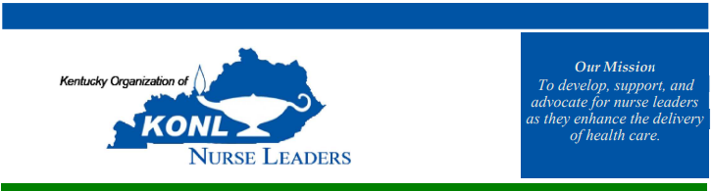

“Nursing Leaders – Champions of Wellbeing”
October 8-9, 2026 | Baptist Health – Lexington KY

Thursday, October 8th
ALL REGISTRANTS
1200-1230 Registration & Visit Vendors & Poster Presentations
1230-1245 Welcome – Deanna Parker & Dee Beckman
1245-1415 Renee Thompson – Keynote Address
1415-14:45 Break – Visit Vendors & Poster Presentations
1445-1530 Tonya Goodin – Leadership Presence That Matters: Connecting Purposeful Nurse Leader Rounding, Patient Experience, and Nurse Well-Being
1530-1545 Mini/Stand-up Break
1530-1615 Amy Mattingly – Art Therapy: Stress and Resiliency Mapping
1615-1630 Closing of Day One Announcements & Introduce “Reflection Stations”
1800 Social Event – Location TBD

“Nursing Leaders – Champions of Wellbeing”
October 8-9, 2026 | Baptist Health – Lexington KY

Friday, October 9th
0815-0845 Continental Breakfast
0845-0900 Welcome & “Reflection Stations” Reminder– Sally Davenport
0900-1000 Kay Kennedy – “Thriving Cultures Start Here: Human-Centered Leadership in Healthcare”
1000-1015 Mini/Stand-up Break
1015-1115 Kay Kennedy - “Human-Centered Leadership in Healthcare – Identify A Change YOU Can Make”
1115-1130 Mini/Stand-up Break
1130-1215 KONL Membership Meeting & Awards Presentation
1215-1300 Luncheon & “Reflection Stations”
1300-1345 Shanda Sutherland – “The Effect of a Mindfulness Based Stress Reduction Program on Stress and Burnout
Among Medical Surgical Nurses: A Quasi-Experimental Approach”
1345-1400 Mini/Stand-up Break
1400-1445 Joey Burke - Navigating Moral Distress: The Nurse Leader’s Role in Supporting Staff Wellbeing
1445 - Closing Remarks – Deanna Parker

