Subject line: New NDNA Member Benefit: Free Social Security Webinar

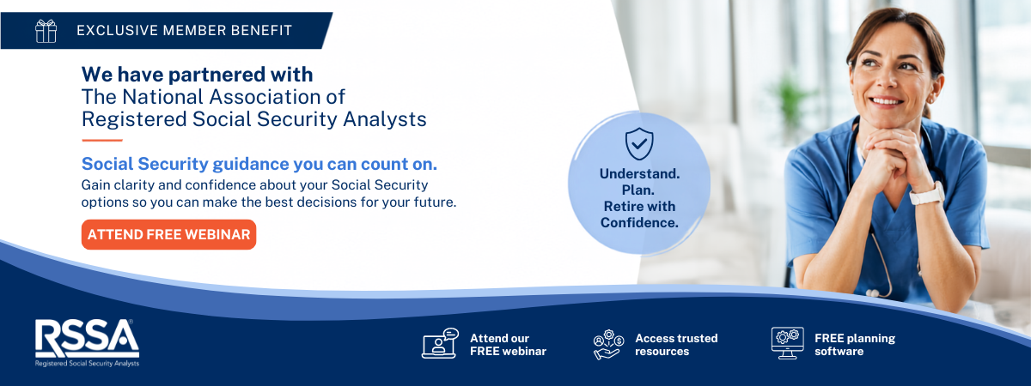
Dear NDNA Members,
We're excited to announce a new member benefit through our partnership with the National Association of Registered Social Security Analysts® (NARSSA®).
As part of this partnership, every NDNA member and their family now has access to a free Social Security Financial Wellness Benefit designed to help you better understand your Social Security options and make more informed retirement decisions.

Your New Member Benefits

✔ Complimentary Social Security Planning Tool
Receive free access to the RSSA Roadmap®, an easy-to-use planning tool that helps you explore your Social Security claiming options and understand how different decisions may impact your retirement.
The RSSA Roadmap® is provided by NARSSA as part of its consumer advocacy mission to help Americans navigate the complexities of Social Security. There is no cost, no obligation, and no sales requirement—just education, planning resources, and expert support.

✔ Complimentary Consultation with a Registered Social Security Analyst® (RSSA®)
You also have the opportunity to schedule a complimentary conversation with an RSSA® (Registered Social Security Analyst®)—a professional who has completed advanced education focused specifically on Social Security planning.
Your RSSA can answer your questions, explain your options, and help you better understand how Social Security fits into your overall retirement plan.

Meet Your Dedicated NDNA RSSA®
We're pleased to introduce Thomas Beno, RSSA®, your dedicated Social Security resource for NDNA members.
Thomas is a Registered Social Security Analyst® and Advanced Planning Consultant with more than 20 years of experience helping individuals and families make informed financial decisions. He specializes in Social Security planning, retirement income strategies, tax-efficient planning, and legacy planning. During your complimentary consultation, Thomas will take the time to understand your unique situation and answer your Social Security questions.

Join Our Free Educational Webinar
To introduce this new member benefit, Thomas will be hosting two live webinar sessions—offered at different times to accommodate members' schedules.
During the webinar, you'll learn:
- Understanding your Social Security options
- Common claiming mistakes to avoid
- How Social Security fits into your overall retirement plan
- Live Q&A

Wednesday, August 5
10:00 AM Central / 11:00 AM Eastern
Register:
https://us06web.zoom.us/webinar/register/WN__T5JzD0CTRa9PYtP_EAFvg

Wednesday, August 5
4:00 PM Central / 5:00 PM Eastern
Register:
https://us06web.zoom.us/webinar/register/WN_2GP-jq5mQxCaVs_aXvbHUA

Visit the NDNA Social Security Resource Center
https://rssa.com/ndna/
From this page you can:
- Register for your free RSSA Roadmap®
- Schedule a complimentary consultation with Thomas Beno, RSSA®
- Register for either webinar
- Learn more about this new NDNA member benefit
Whether retirement is just around the corner or still years away, understanding your Social Security options is an important part of your overall financial wellness. We encourage you to take advantage of this valuable new member benefit.
We look forward to bringing you additional educational resources through this partnership.
Sincerely,
The North Dakota Nurses Association

