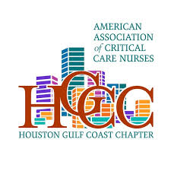
AACN Houston Gulf Coast Chapter Invites You To an Educational Chapter Meeting

Where: King Ranch Texas Kitchen
1605 Post Oak Blvd.
Houston, TX, 77056

Topic: Therapeutic Wound Cleansing
Sponsor: Mackensie Wood, Urgo Medical North America
Speaker: Rachel Hodges, CWCA
When: August 6, 2026
Registration begins at 6:30pm, Presentation at 7pm
Register on Nursing Network
Seats are limited, so sign up soon to secure your spot!

