A Virtual Webinar
The Inverted Pyramid customized

Join us Thursday, November 19th 2026 from 2:00 – 4:30 pm ET for
The Inverted Pyramid: Leading Teams of Novice Nurses

Presented by Dr. Rose Sherman, Ed.D., RN, NEA-BC, FAAN
Nursing Leadership Development Expert & Author

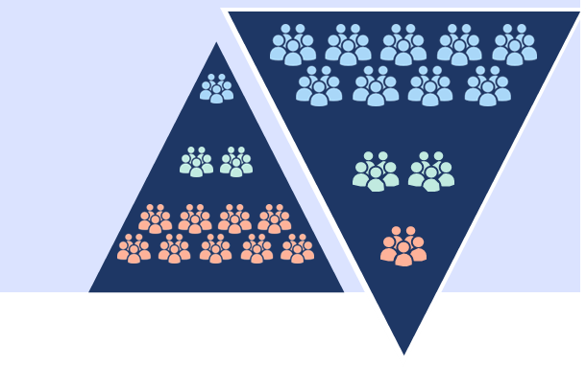
Nursing faces a structural crisis in many healthcare settings as patient acuity has risen, and staff experience has declined. Historically, a solid base of veteran "expert" nurses supported a small group of novices.
Today, the model has flipped into an inverted pyramid. Most frontline nurses in acute care environments are novice clinicians, supported by a shrinking minority of experienced clinicians.

This interactive workshop provides leaders with concrete strategies to manage patient care and coach clinically inexperienced teams. Participants will learn how to rebuild systems of safety to ensure quality care in an environment where experienced nurses
are rare and at a premium.

Topics include:
- New viewpoints about nursing careers
- The impact of a leader-coach mindset in team support
- How to build structural safety and cognitive support for your teams
- Managing the “experienced minority” to promote their engagement

COST: NYONL members: $99 Non-Members: $125
Group Discount: 10 attendees from the same organization: $1,000 *
* For group registrations, contact us: https://nyonl.nursingnetwork.com/contact

Register here: https://nyonl.nursingnetwork.com/nursing-events/152626-the-inverted-pyramid-leading-teams-of-novice-nurses#!registration

This conference is jointly provided by NYONL and the University of Rochester Medicine Accredited Provider. University of Rochester Medicine is accredited as a provider of nursing continuing professional development by the American Nurses Credentialing Center’s Commission on Accreditation.
This offering provides 2.5 ANCC CNE credits to attendees at the full session.


