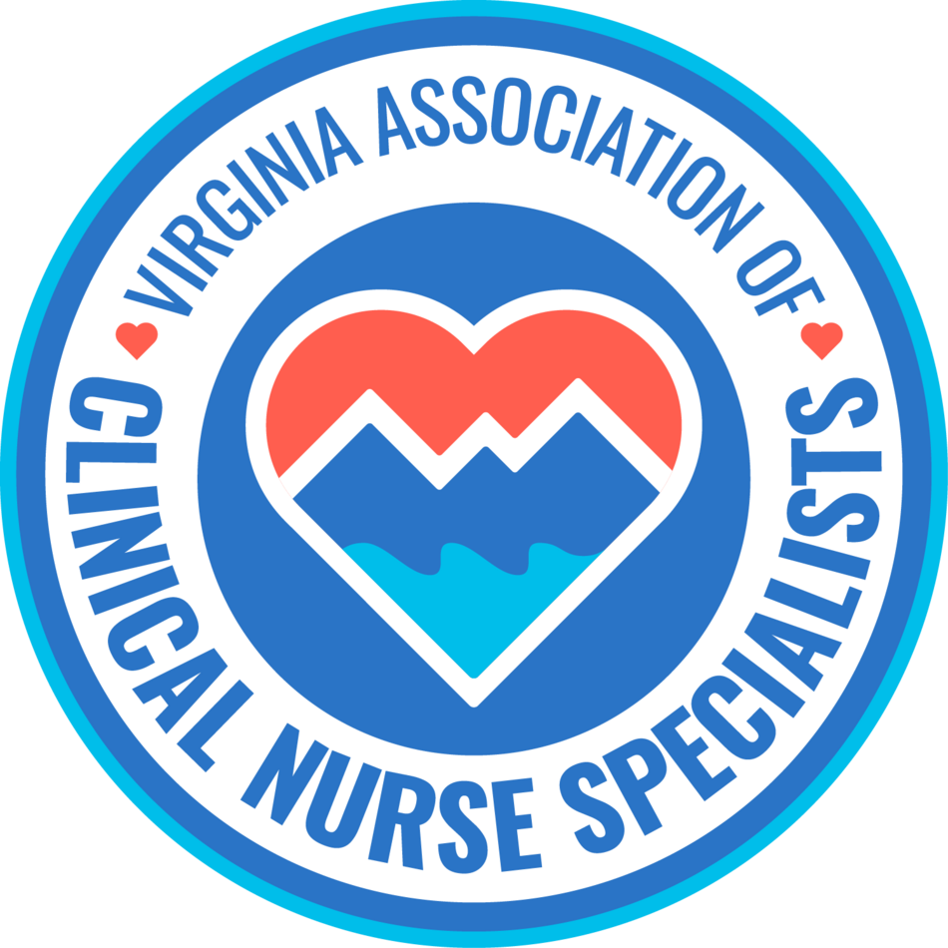
Our Mission:
Promote the role of the clinical nurse specialist as an advanced practice registered nurse in Virginia, and improve systems of care, prevent disease, and enhance health
and well-being through evidence-based population care.

MEMBERSHIP MEETING AGENDA
July 13th, 2026
6:00 pm to 7:00 pm

Zoom Meeting:
https://us02web.zoom.us/j/611829893?pwd=Tkl1aWJOY0JhelVkMUlUaFpkK0MrZz09

Phone number 1-929-205-6099; Meeting ID: 611 829 893 Passcode: 329587

Discussion Items | Facilitator
Welcome & Announcements  - Introductions  - Member achievements | Sarah Taylor/Members  Sandra (Dea) Mahanes-Dr. Mahanes was selected for induction into the American Academy of Nursing as a fellow.
Minutes  • Approval of minutes | Ellen Harvey
Reports  • Treasurer  • Social Media  • Standing Committees  - Finance  - Program Planning  - Growth & Succession  ● Volunteer Forms  - Legislative/Regulatory  - Open discussion  - Future topics of discussion  - Guest speakers | Sarra Wildermuth  Cindy Ward  Holly Tenaglia  Stacia Landrom & Trina Carter  Amy Lucas  Erin Smith  Group  Sarra Wildermuth  Neuroscience CNS @ ECU Health-Discusses her journey of building a EMU at ECU Health.
New Business:
Next membership meeting: | August 10th, 2026, 6:00 pm

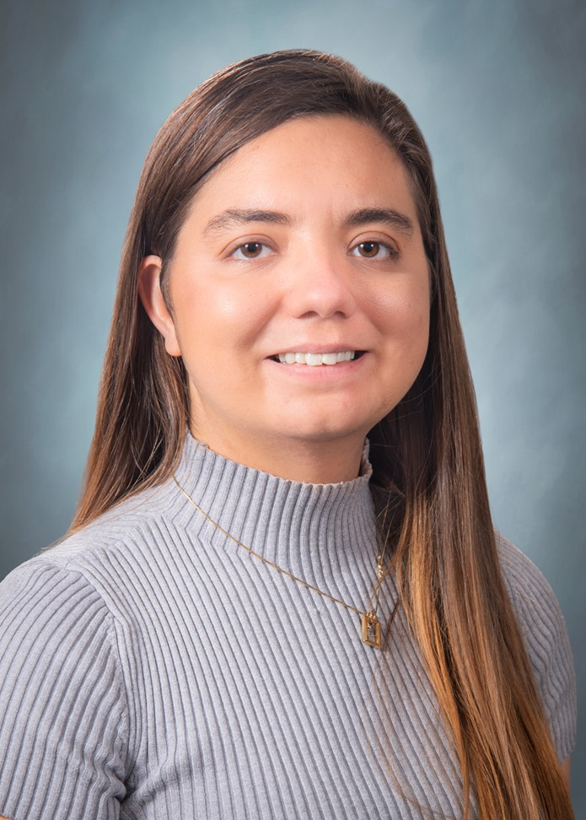

Sarra Wildermuth, MSN, RN, ACCNS-AG is a Neuroscience Clinical Nurse Specialist at ECU Health in Greenville, North Carolina. She specializes in the care of patients with epilepsy, traumatic brain injury, and stroke; with a focus on evidence-based practice and interdisciplinary collaboration.
Sarra maintains strong professional connections to Virginia, where she worked as a bedside nurse for five years and earned her Clinical Nurse Specialist degree from Old Dominion University. She is passionate about supporting the VaCNS organization and remains dedicated to enhancing collaboration among CNSs in both North Carolina and Virginia.

