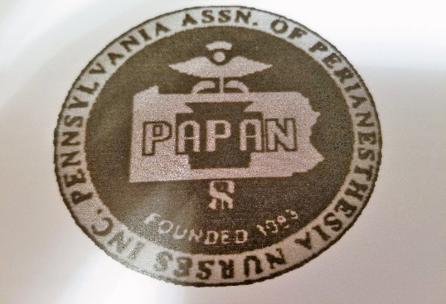PAPAN 2026-2027 BOARD
PRESIDENT: CRISTINA BROOKS
VICE-PRESIDENT: ESMIHAN ALMONTASER
SECRETARY: KAITLIN RONNING
TREASURER: KAITLIN KRAMMES
IMMEDIATE PAST-PRESIDENT: DENISE KRALL
BOARD OF DIRECTORS: CHERYL RIVERS
ANDREW ADDISON
WENDY GAYMAN-GRANT
JAMES HYNES
STACI STONER
CONGRATULATIONS TO THE NEW BOARD!!

