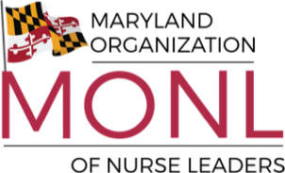
⚡ FLASH SALE! ⚡
Join or Renew Your MONL Membership and Save!
🎉 For a Limited Time Only
Annual Membership
➜ $120
Use Promo Code: MONLJULY26
📅 Sale Ends: Wednesday, July 15, 2026

Why Join MONL?
✔ Professional Development & Educational Programs
✔ Networking with Nurse Leaders Across Maryland
✔ Advocacy and Legislative Engagement
✔ Awards, Scholarships, and Recognition Opportunities
✔ Access to Exclusive Resources and Events

Don't Miss Out! Become part of Maryland's premier organization for nurse leaders and take advantage of this special savings.
📲 Join Today: https://mdonl.nursingnetwork.com/page/54531-membership-information-benefits (Enter code MONLJULY26 at checkout)
📧 Questions? Email: mdnurseleaders@gmail.com 