AORN of GREATER CLEVELAND
LaVera Dinner Fundraiser
Monday October 19th, 2026
Please help support our nursing scholarships, outreach programs, and our chapter education.
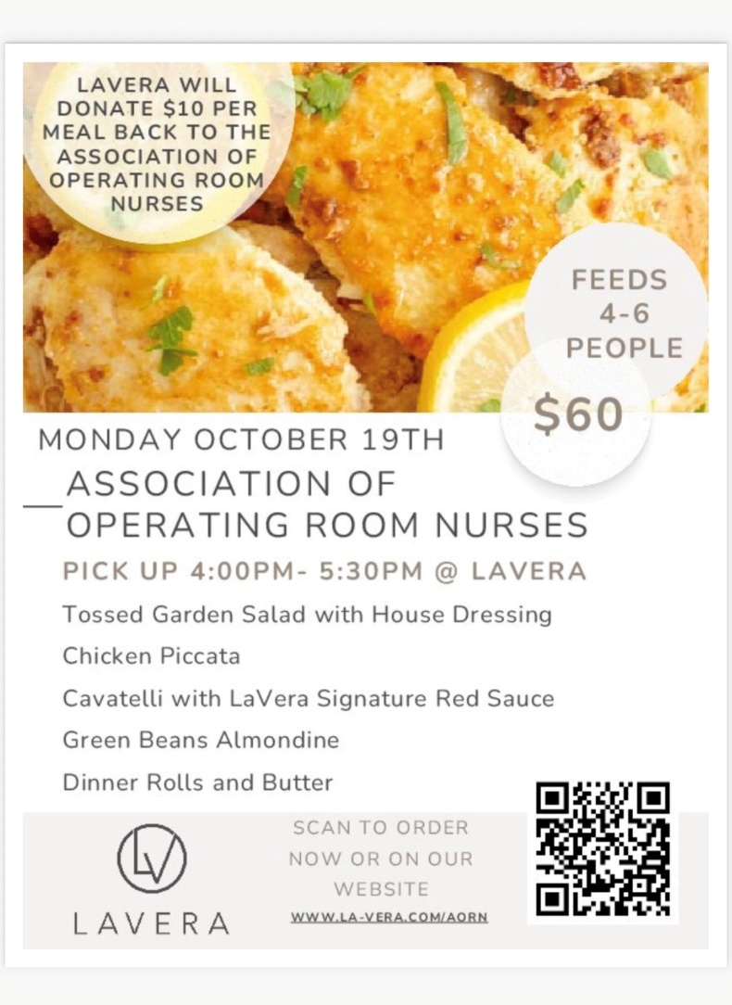
Please share this opportunity to enjoy a delicious meal without cooking with your family and friends. Order by 9pm Sunday October 18th.
https://www.la-vera.com/nurse
LaVera Party Center
32200 Chardon Road
Willoughby Hills, Ohio 44094
440-943-0087

