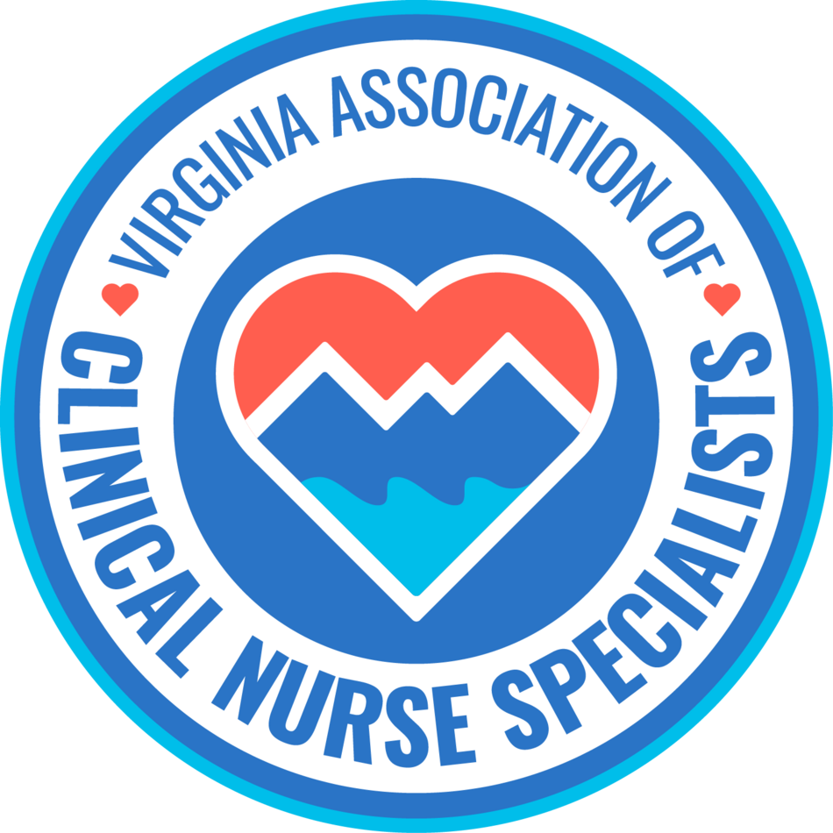
Our Mission:
Promote the role of the clinical nurse specialist as an advanced practice registered nurse in Virginia, and improve systems of care, prevent disease, and enhance health
and well-being through evidence-based population care.

MEMBERSHIP MEETING AGENDA
June 11th, 2026
6:00 pm to 7:00 pm

Zoom Meeting:
https://us02web.zoom.us/j/611829893?pwd=Tkl1aWJOY0JhelVkMUlUaFpkK0MrZz09

Phone number 1-929-205-6099; Meeting ID: 611 829 893 Passcode: 329587

Discussion Items | Facilitator
Welcome & Announcements  - Introductions  - Member achievements | Sarah Taylor/Members
Minutes  • Approval of minutes | Ellen Harvey
Reports  • Treasurer  • Social Media  • Standing Committees  - Finance  - Program Planning  - Growth & Succession  - Legislative/Regulatory  - Open discussion  - Future topics of discussion  - Guest speakers | Sarra Wildermuth  Cindy Ward  Holly Tenaglia  Stacia Landrom & Trina Carter  Amy Lucas  Erin Smith  Group  Daniell Kempton  Emergency & Critical Care Clinical Nurse Specialist
New Business:
Next membership meeting: | July 13th, 2026, 6:00 pm


Daniell Kempton, MSN
Emergency & Critical Care Clinical Nurse Specialist
Inova Fair Oaks Hospital

The Rollercoaster Ride of Overdosing on Calcium Channel Blockers: A Case Study
