ICORN and AORN IL Chapters Mini-Vendor Fair @Topgolf Schaumburg
2050 Progress Pkwy, Schaumburg IL 60196
May 31, 2026, 1-5pm
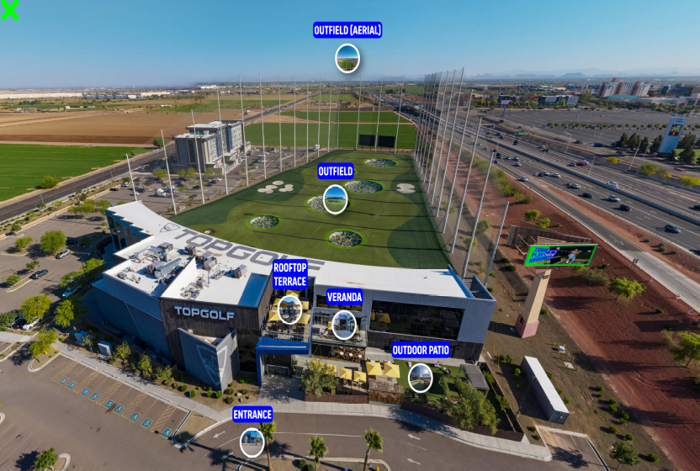

Includes:
Vendor Fair, Auction, 3 Hrs golfing,
Modern Mediterranean Lunch (Golden Spice Chicken, Grilled Steak, Lemon Rice,
Shredded Lettuce, Grilled Vegetable Medley, Flatbread Wedges, Crumbled Feta, Pickled Red Onion, Baba Ghanoush, Tzatziki, Roasted Red Pepper Hummus, Pesto Orzo Salad, Cucumber Tomato Salad, Marinated Olives, Fountain Soda, Iced Tea, Coffee and Water)
Hard drinks _Cash Bar

Early Bird Registration by May 5th
$50/per person
Registration from May 6th-20th

$60/per person

You must register via Nursing Network (QR code above) and pay via Zelle to Chapter 1401 treasurer, Hannah Nicholson at 773-899-6066

For further info_Email us using title_ Top Golf:
Tiana Dunlap: tianadunlap@gmail.com
Carlo Butacan: cbutacan@gmail.com
Hannah Nicholson: hmnicholson29@gmail.com

