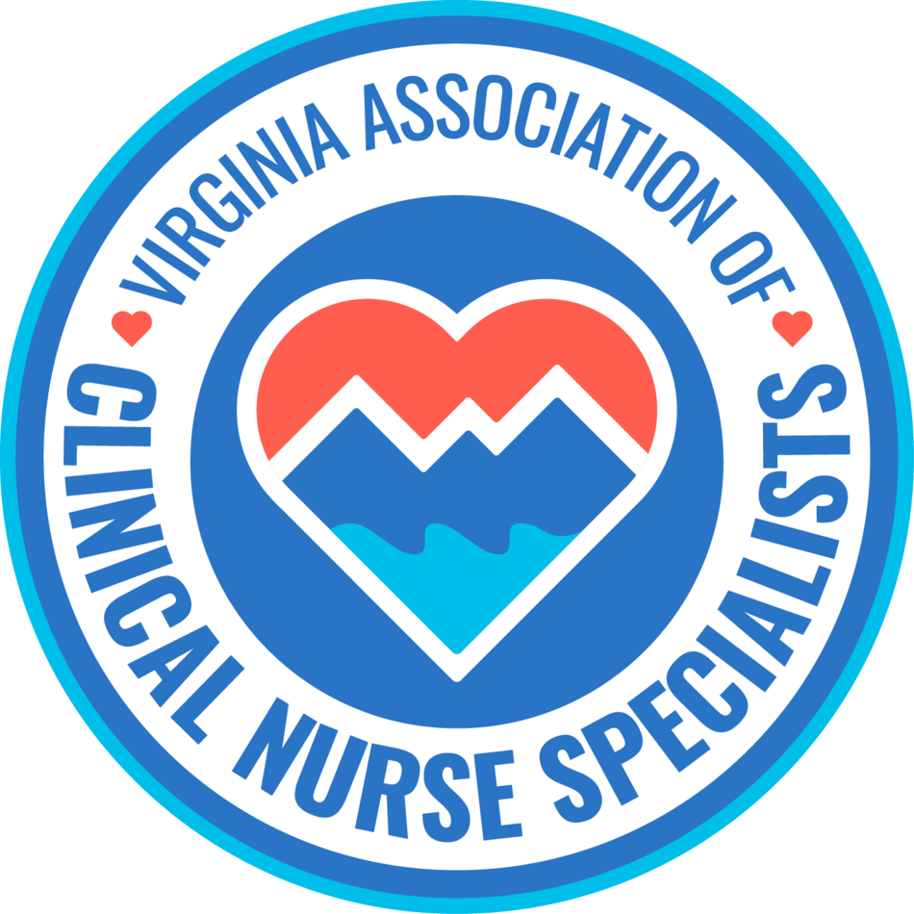
Our Mission:
Promote the role of the clinical nurse specialist as an advanced practice registered nurse in Virginia, and improve systems of care, prevent disease, and enhance health
and well-being through evidence-based care of populations.

MEMBERSHIP MEETING AGENDA
May 11th, 2026
6:00 pm to 7:00 pm

Zoom Meeting:
https://us02web.zoom.us/j/611829893?pwd=Tkl1aWJOY0JhelVkMUlUaFpkK0MrZz09

Phone number 1-929-205-6099; Meeting ID: 611 829 893 Passcode: 329587

Discussion Items | Facilitator
Welcome & Announcements  - Introductions  - Member achievements | Sarah Taylor/Members
Minutes  • Approval of minutes | Ellen Harvey
Reports  • Treasurer  • Social Media  • Standing Committees  - Finance  - Program Planning  - Growth & Succession  - Legislative/Regulatory  - Open discussion  - Future topics of discussion  - Guest speakers  - Link to the CNSI website: https://nacns.org/cns-institute/cnsi-fellowship/ | Sarra Wildermuth  Cindy Ward  Holly Tenaglia  Shelley Milburn/Lauren Turner  Amy Lucas  Erin Smith  Group  Amanda Golino, DNP, APRN, CCRN, CCNS, PMGT-BC, TCRN, FCNS
New Business:
Next membership meeting: | June 8th, 2026, 6:00 pm

 Inova Healthcare

Amanda Golino, DNP, APRN, CCRN, CCNS, PMGT-BC, TCRN, FCNS

Amanda’s passion is improving patient outcomes through quality, evidence-based nursing care for acute and critically ill patients. As a clinical nurse specialist, I have been involved in research, project management, quality improvement, and education initiatives in the acute and critical care setting.
She received her MSN and CNS certification from Liberty University and her DNP from UVA. She also holds certifications in Trauma nursing care, critical care, and pain management. Amanda is a CNSI fellow.
CNSI Fellow Program Applications
CNSI Fellow Program Applications are accepted from June through September 30, 11:59 EST each year.
2026 Fellow Induction Ceremony Booklet
2025 Fellow Induction Ceremony Booklet
CNSI Fellow Program Application Instructions
Guidelines to Completing the Fellow Program Application
Click here to download a file with all CNSI Fellows and their induction year.

