AORN OF MAYWOOD
CHAPTER 1424
MEETING
Join us for dinner and education:
Thursday, June 18th, 2026
Maggiano’s Restaurant
5:30-6:00: Sign in and networking
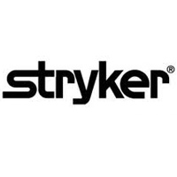
6:00-6:30: AORN Meeting
6:30-7:30: Dinner and Education sponsored by:
Ben Hollerbach, Erin Madigan, Hanna Maher, Mallory Laumann, and John Barr, representatives from Stryker

*Membership Required for Event*
Attendance limit: 30 members and guests
PLEASE RSVP USING THE QR CODE BELOW IN NURSINGNETWORK.COM


