North Dakota Nurses Association (NDNA) Partners with The Mental Hygiene Project (MHP) to Support Well-Being and Mental Resilience for the Nursing Profession.
Bismarck, ND — April 2026
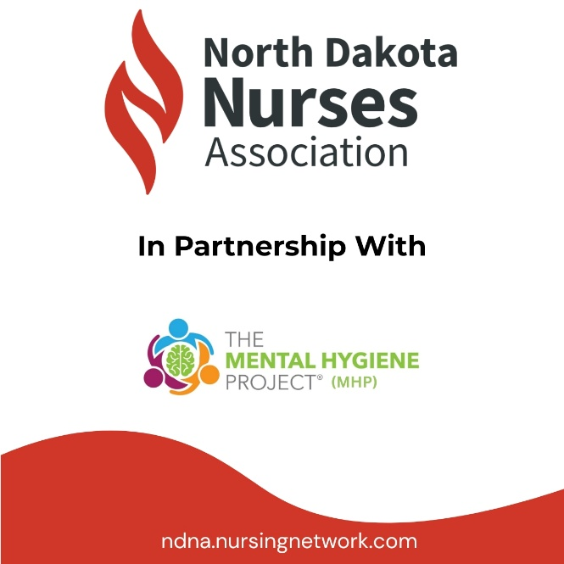
Today, NDNA is announcing a partnership with The Mental Hygiene Project™ (MHP) as part of our Association's plan to actively address and support well-being and mental resilience in the nursing profession.
The MHP works with healthcare organizations to provide educational training on leadership, emotional intelligence, and mental resilience. We help individuals, teams, and organizations understand the long-term impact of traumatic exposure, stress, and compassion fatigue, and develop practical and transformational approaches to support healthcare professionals, strengthen organizational resilience, and promote sustainable well-being. Learn more about MHP at www.mentalhyieneproject.com
“After working in the field as a paramedic, and later as a bedside/ER nurse and nurse educator for over 20 years, I understand how our nurses are stressed out and burned out from the compassion fatigue and long shifts they work,” said Dr. Penny Briese, Executive Director of the North Dakota Nurses Association. “Nurse readiness is the core of what we do here at NDNA, yet we also want to recognize the importance of making well-being and mental resilience part of that readiness.”
“Strengthening individual and team resilience must go beyond the employee assistance program. It’s time we take the appropriate steps to help support those who help others. We can no longer leave mental health and well-being on the sidelines; we must actively pursue pathways that build a culture of health and well-being, rather than default to sub-cultures that continue to have negative human and financial impact,” said Ryan Gallik, Managing Partner of The Mental Hygiene Project™.
“Programs that give leaders practical ways to support their team can make a meaningful difference across an organization,” stated Michael Stahl, Managing Partner at MHP. “We’re pleased to work alongside NDNA to help connect nurses with resources that support their teams.”
The partnership reflects the North Dakota Nurses Association’s commitment to working with trusted organizations that provide valuable expertise to healthcare professionals. By collaborating with partners across the industry, NDNA helps nurses and hospitals access resources that complement patient experience while supporting the people behind the work.
More information about the partnership and available resources will be available on the NDNA website at https://ndna.nursingnetwork.com/
About NDNA
The North Dakota Nurses Association (NDNA) is the only professional organization representing all nurses in North Dakota. The Mission of NDNA is to advance the nursing profession by promoting professional development of nurses, fostering high standards of nursing practice, promoting the safety and well-being of nurses in the workplace, and by advocating on health care issues affecting nurses and the public.
Media Contact:
Dr. Penny Briese, PhD, MS, BSN, RN, CHSE Executive Director North Dakota Nurses Association
director@ndna.org 701-320-0010

About The Mental Hygiene Project™
The Mental Hygiene Project™ (MHP) works with healthcare organizations through online training, workshops, leadership engagement, and structured program guidance. MHP helps agencies understand the long-term impact of traumatic exposure and develop practical approaches to support personnel, strengthen organizational resilience, and promote sustainable wellness initiatives. Learn more about MHP at www.mentalhygieneproject.com.
Media Contact:
Ryan Gallik, Managing Partner
rsgallik@ryangallik.com 352-434-9119

