2025-2026 GRAC Educational Needs Assessment
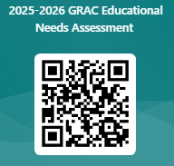

https://forms.office.com/r/McbSeTBMqC


Complete the 2025-2026 educational needs assessment by May 31, 2026 to give feedback on GRAC programs and offerings from the past year to help us build for next year! Include your email and enter a random drawing to win a $25 Amazon gift card!

