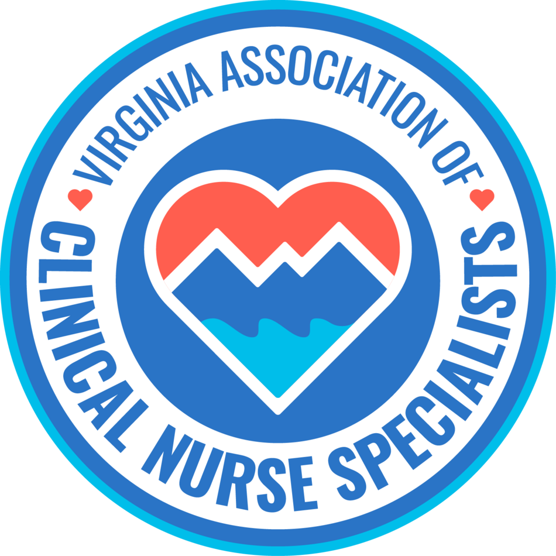
Our Mission:
Promote the role of the clinical nurse specialist as an advanced practice registered nurse in Virginia, and improve systems of care, prevent disease, and enhance health
and well-being through evidence-based care of populations.

MEMBERSHIP MEETING AGENDA
April 13th, 2026
5:00 pm to 6:00 pm

Zoom Meeting:
https://us02web.zoom.us/j/611829893?pwd=Tkl1aWJOY0JhelVkMUlUaFpkK0MrZz09

Phone number 1-929-205-6099; Meeting ID: 611 829 893 Passcode: 329587

Discussion Items | Facilitator
Welcome & Announcements  - Introductions  - Member achievements | Sarah Taylor/Members
Minutes  • Approval of minutes | Ellen Harvey
Reports  • Treasurer  • Social Media  • Standing Committees  - Finance  - Program Planning  - Growth & Succession  - Legislative/Regulatory  - Open discussion  - Future topics of discussion  - Guest speakers | Sarra Wildermuth  Cindy Ward  Holly Tenaglia  Shelley Milburn/Lauren Turner  Amy Lucas  Erin Smith  Group  Stacia Landrum,DNP, MSN, AGCNS, CDCES, BCADM
New Business: meeting time will change on May 11th to 6pm-7pm
Next membership meeting: | May 11th, 2026, 6:00 pm

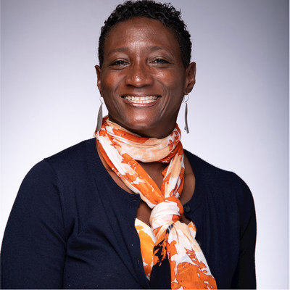
Stacia Landron, DNP, MSN, AGCNS, CDCES, BCADM

Stacia Landrom is an Advanced Practice Registered Nurse and Clinical Nurse Specialist specializing in diabetes management. She earned her Bachelor of Science in Nursing from Eastern Michigan University and her Master of Science in Nursing from the University of Michigan. Most recently, she completed her Doctor of Nursing Practice as an Adult-Gerontology Clinical Nurse Specialist at Johns Hopkins University School of Nursing. Stacia began her diabetes care work as a Certified Diabetes Care and Education Specialist (CDCES) in the inpatient setting, where she built a strong foundation in patient-centered education and management. She is proud to continue her passion for improving diabetes outcomes as part of the Bon Secours Program for Diabetes Health.
Stacia has experience across a variety of care settings, including inpatient glycemic management, acute care, home care, behavioral health, and hospice. She believes that interdisciplinary collaboration and person-centered care are crucial to improving glycemic outcomes. Stacia is a member of the Sigma Theta Tau International Honor Society of Nursing, the American Nurses Association, the National Association of Clinical Nurse Specialists, and the Virginia Association of Clinical Nurse Specialists. She is Board Certified in Advanced Diabetes Management (BCADM) and a Certified Diabetes Care & Education Specialist (CDCES).

