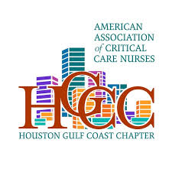
AACN Houston Gulf Coast Chapter Invites You To an Educational Chapter Meeting

Where: Mexican Sugar Cocina
3505 W. Dallas St. Houston, TX 77019
Houston, TX, 77019

Topic: Zoll Solution Across the Continuum of Care
Sponsor: Zoll Medical
Speakers: Allison Arnold, MBA, MSN, RN
Samantha Davis, Territory Manager | TX, NM, AZ
Reggie Smith, Regional Sales Manager-Houston South

When: May 7, 2026
Registration begins at 6:30pm, presentation at 7pm
Register on Nursing Network
Seats are limited, so sign up soon to secure your spot!

