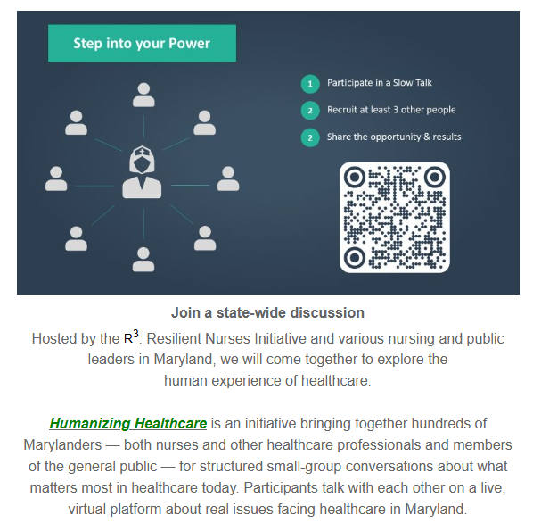

To register, scan the QR code above or visit
https://www.slowtalk.us/humanizing-healthcare

