We need nursing students to join a state-wide discussion!

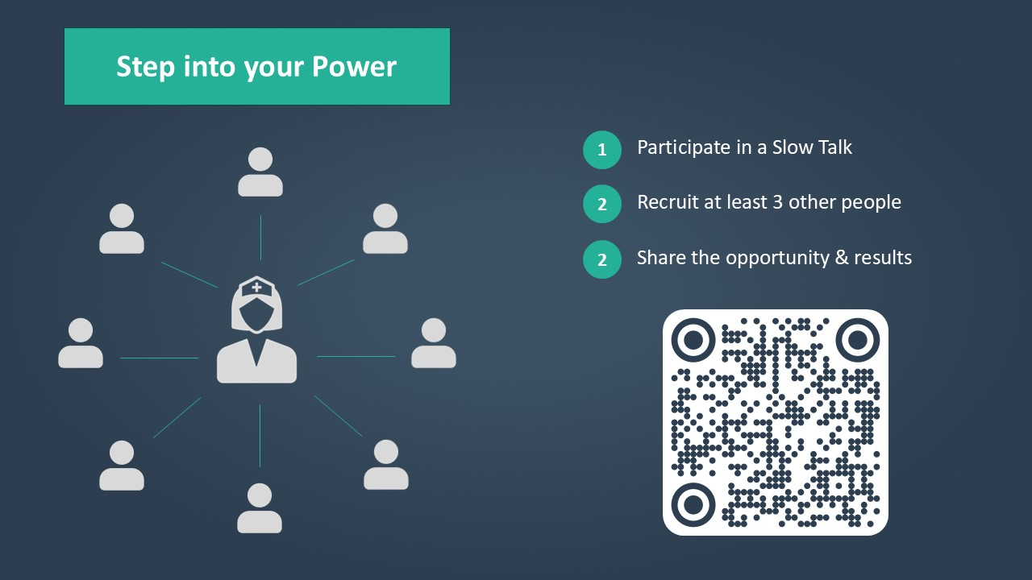

Hosted by the R³: Resilient Nurses Initiative and various nursing and public leaders in Maryland, join us to explore the human experience of healthcare.
Humanizing Healthcare is an initiative bringing together hundreds of Marylanders — nurses, students, and other healthcare professionals and members of the general public — for structured small-group conversations about what matters most in healthcare today. Participants talk with each other on a live, virtual platform about real issues facing healthcare in Maryland.

Make a difference! Let your voice be heard!
To register, scan the QR code above or visit
https://www.slowtalk.us/humanizing-healthcare

