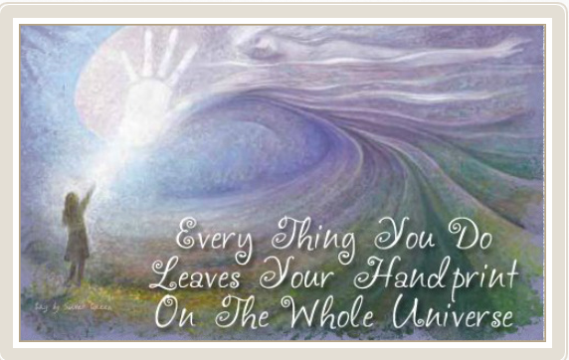

Being a NURSE means......

You will never be bored.

You will always be frustrated.

You will be surrounded by challenges.

So much to do and so little time.

You will carry immense responsibility and very little authority.

You will step into people's lives and you will make a difference.

Some will bless you. Some will curse you.

You will see people at their worst-and at their best

You will never cease to be amazed at people's capacity for love, courage, and endurance.

You will see life begin-and end.

You will experience resounding triumphs and devastating failures.

You will cry a lot. You will laugh a lot.

You will laugh a lot.

You will know what it is to be human and to be humane.

Melodie Chenevert BSN