AORN RNSA |  |  | March 2026 (qtr 1)
Retired Nurses Special Assembly Newsletter
By and for AORN nurses

Please note our group name. We are made up of retired nurses but also include those of you that are taking a break from work for various reasons. As older retired nurses, we offer ourselves as educators, sharers of our years of knowledge and experience. All we need is for someone to ASK, and you will be surprised at what you learn.

https://aornretired.nursingnetwork.com/
This is the link to our new homepage. If you have not signed into the AORN main page, you will probably need to do that to access the nursing network site, which will require another sign-in. Once you have found a group, you have dropdowns on the left that you can explore. Announcements for upcoming meetings or events may be on the front page for the group. Check out the space and explore. Let us know if you have any questions. We’ll help!!
Mission & Vision
The Retired Nurses Specialty Assembly is for perioperative nurses who are retired, in transition toward retirement in their careers, or interested in tapping into the expertise of perioperative nurses with a vast array of experience in a variety of specialties.
- Provide a forum for networking for retired nurses and other members interested in learning about the Retired Nurse SA
- Increase communication and collaboration among nurses who have similar work functions.
- Serve as a resource for AORN in all areas of perioperative nursing.
- Serve as a resource for the membership of AORN on matters concerning retirement.

If you are interested in joining us, or to visit, we are located at https://aornretired.nursingnetwork.com

Nursing Honor Guard

provide a solemn ceremony, often at funerals, to honor deceased nurses by releasing them from their duties, symbolizing their dedication with traditional white uniforms, Florence Nightingale lamp presentation, white roses, and the ring of a triangle, with the National Nurses Honor Guard Coalition coordinating local groups that offer these services free of charge.

What they do
Attend services: They attend funerals, visitations, or memorial services for nurses.
Wear traditional attire: Members wear white uniforms, caps, and capes, similar to historical nursing dress. Each chapter designs their own pin.
Perform the "Final Call": A key part is the "Final Call to Duty," where the nurse's name is called, their service is acknowledged, and they are released from earthly duties, often with a bell or triangle.
Nightingale Tribute: A poem or prayer is recited, and a lit Florence Nightingale lamp is extinguished and presented to the family.
Symbolic gestures: White roses are placed on the casket or urn.
How to find or start one: ask Cheryl or Pat, they are in the know, and if anyone else is in the know, please don’t be afraid to let us know. We don’t bit (not unlike some surgeons we may have come across in our careers)
National Network: The National Nurses Honor Guard Coalition (NFHA) helps families find local chapters.
Contact local hospitals: Many hospitals with nursing programs have their own guards (e.g., Mercy Medical Center).
State nursing associations: Organizations like ANA Illinois provide resources.
Starting a group: Volunteers can form groups, coordinate with funeral homes, and purchase uniforms and lamps, with costs often minimal or covered by the group.
https://nursinghistory.org/nurse-honor-guard/

Lamp of Knowledge
Even though most view the oil lamp as a lesser-known symbol of nursing, most nurses know the oil lamp, or lamp of life, is a symbol of our profession.
Florence Nightingale made so many contributions to the nursing profession throughout her career. One of her earlier contributions was during the Crimean War. Florence Nightingale realized early on that filth was not conducive to healing, and she changed the way medical facilities operated. She was a pioneer of her time, and known for rounding on her patients at night by the light of an oil lamp which is why she is known as “The Lady with the Lamp.” Leading into this next segment:

NIGHT SHIFT GURNEY RACES

You haven’t truly transported a patient…until you’ve wrestled one of those old-school monsters, known as the squeakey wheel stretcher, down a polished hospital hallway. These new ones? They glide. The old ones? They had ATTITUDE.
One strong push out of the room and suddenly—You’re not walking. You’re negotiating with physics. That stretcher would start rolling like it had a shift to finish and no time for your hesitation. No power steering. No smooth brakes. Just that metal frame rattling like it was announcing your arrival to the entire floor. And don’t let there be a slight slope in the hallway…Because now you’re half jogging, half praying, whispering: “Slow down… slow down… we are professionals…”

Corner coming up? You leaned your whole body into that turn like you were driving a delivery truck or at the Indy 500 or Daytona raceway, jockeying for position, attepmting to avoid the wall!!!! And heaven help you if the elevator doors opened late. Look out, make sure you aren’t the lead ‘car’-gurney! But somehow —with pure muscle, timing, and determination —we got every patient where they needed to be. No technology. Just teamwork and grit. Those stretchers didn’t just build forearm strength…They built reflexes. Confidence. Instinct. Different era. Different equipment. Different kind of toughness. To the nurses who survived the runaway stretcher days — you don’t panic… you pivot. That kind of skill never leaves you, no matter where you work or have worked, no matter how many shifts or transport for those patients. Sometimes, if we could maniuplate it, we’d bring in the groceries for the communal fridge.



Member Spotlight
Any one want to step up?

Food FOOOD FOOOD YUMMY FOOD
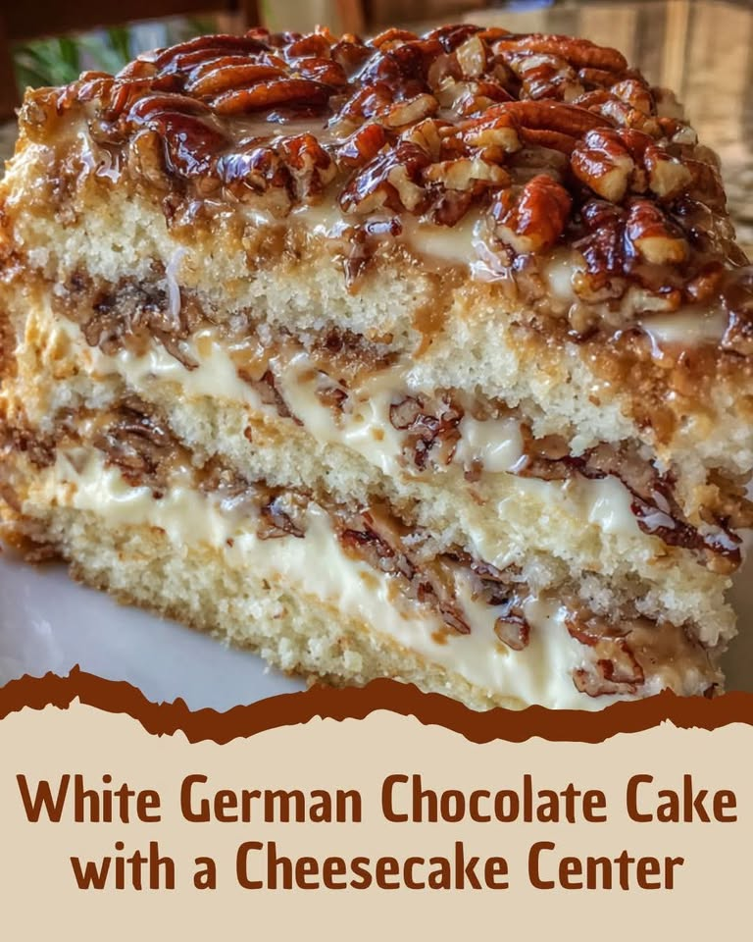

This decadent cake features a creamy cheesecake layer nestled between soft white cake and topped with a rich coconut-pecan frosting—a showstopping dessert perfect for any occasion.
While this is a definite delicious cake, allow yourself 2 days to complete the prep. And tell us how it tastes!!!!
Ingredients:
For the Cheesecake Center:
16 oz cream cheese, softened
½ cup granulated sugar
½ teaspoon vanilla extract
2 large eggs
For the White Cake:
1 box white cake mix (15.25 oz)
1 cup water
½ cup vegetable oil
3 large egg whites
For the Coconut-Pecan Frosting:
1 cup evaporated milk
1 cup granulated sugar
3 large egg yolks
½ cup unsalted butter
1 teaspoon vanilla extract
1½ cups sweetened shredded coconut
1 cup chopped pecans

Instructions
1. Make the Cheesecake Layer:
Preheat oven to 325°F (160°C). Grease and line an 8-inch round cake pan with parchment paper.
In a large bowl, beat cream cheese until smooth. Add sugar and vanilla extract; beat until combined. Add eggs one at a time, mixing well after each.
Pour into prepared pan and bake for 35–40 minutes, or until set. Cool completely, then refrigerate until firm.

2. Make the White Cake: preheat oven 350⁰F
Prepare the cake batter according to box instructions using water, oil, and egg whites (save yolks for frosting.
Divide batter evenly between two 8-inch round cake pans.
Bake at 350°F (175°C) for 25–30 minutes, or until a toothpick comes out clean. Cool completely.

3. Make the Frosting:
In a saucepan over medium heat, whisk together evaporated milk, sugar, egg yolks, and butter.
Cook, stirring constantly, until thickened (about 10 minutes).
Remove from heat and stir in vanilla, coconut, and pecans. Cool to room temperature.

4. Assemble the Cake:
Place one white cake layer on a serving plate.
Gently place the cheesecake layer on top.
Add the second white cake layer.
Spread the coconut-pecan frosting over the top and sides.
Prep time: 45 minutes over 2 days | Bake time: 1 hour over 2 days | Chill time: 1–2 hours over 2 days| Total time: approx. 3 hours over 2 days
Serves: 12–14



WHAT IS THIS? WILL BECOME A CONTINUED FEATURE.
So, if you have a strange something that you would like to share, send to Pam (me) and I’ll add to the newsletter.

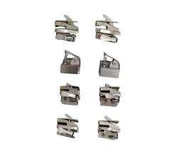

Study this image below, not the one above

And then ask yourself (provided you notice something wrong), would you want this person operating on you or a family member? How many issues do you see?

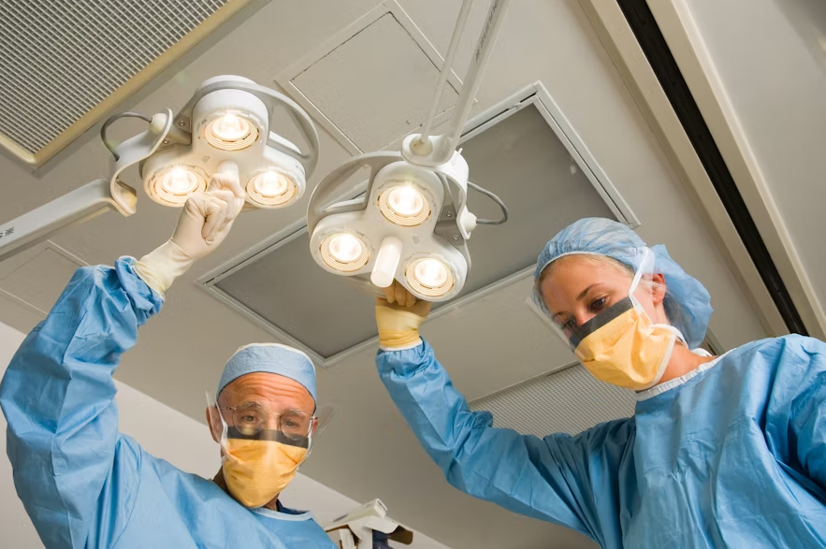

Comments and/or RNSA Newsletter materials, suggestions, etc., are welcome and may be sent to:
Pamayla Darbyshire usafrnped@yahoo.com
Thank you to all contributors.

RNSA Council:
Chair: Cheryl Sumner, RN, CNOR (e) (OH)
Chair-Elect: Cheryl Sumner, RN, CNOR (e) (OH)
Past Chair: Cathy Ostroski, DNP, RN, CENP (NJ)
RNSA Mentor: Joanne D. Oliver-Coleman, MBA-HM, BSN, RN, CNOR (e) (TX)
Board Liaison: David Reinhart, DNP, MBA, RN, CNOR, FAAN
Communications Chair: Patricia Moody, RN, CNOR (e) (IN)
Communications Chair-Elect: Patricia Moody, RN, CNOR (e) (IN)
Education Chair: Melanie Burton, BSN, RN, CNOR, MLSO (WA)
Education Chair-Elect: Melanie Burton, BSN, RN, CNOR, MLSO (WA)
Newsletter: Pamayla E. Darbyshire, DHA, MSN/CNS (UT)

For those that like to read or listen to audiobooks:

Libby App: Free ebooks & audiobooks from your library

OverDrive https://www.overdrive.com
You can Access thousands of free ebooks & audiobooks online with Libby, the library reading app by OverDrive. Enjoy free reading & listening on any device.

