ASPAN Town Hall Meeting: One Voice. One Vision - Moving Forward Together
March 10 | 7:00 PM EST
Open to All Members

Join ASPAN leadership for an important and engaging Town Hall focused on our upcoming reorganization plan.

During this session, we will share the rationale behind the proposed changes, provide an overview of the plan, and outline how this work positions ASPAN for long-term success. You’ll also have the opportunity to ask questions and share your thoughts.

Participating in the discussion will be ASPAN leaders and the Chairs of the Enhancing Organizational Capacity (EOC) Strategic Work Team, who have led this initiative over the past several years. Their work is centered on strengthening ASPAN’s foundation and ensuring we are well-prepared for the future.

We encourage all members to review the reorganization section of the website prior to the meeting to learn more about the proposal. Your engagement is important, and we hope you will join us to be part of this conversation. If you are unable to attend, the session will be recorded and made available for later viewing.

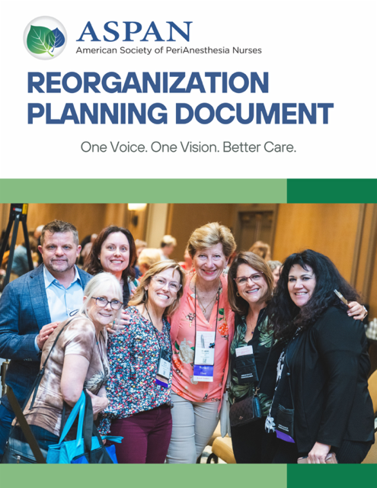

﻿Thank you for your continued commitment to ASPAN and for being an essential part of our community.

Register Now

