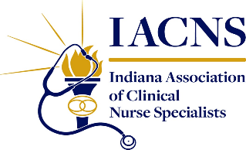
Legislative/Regulatory Committee Update
Created: March 6, 2026
The 124th General Assembly has adjourned as of Friday, February 27th.
General Session Highlights:
There was a total of 917 bills introduced in the House and Senate this past session. Of those, 177 bills were passed and are now awaiting action by the Governor. Many health care policy bills were focused on strengthening public assistance oversight, enhancing patient safeguards, improving government efficiencies and clarifying Indiana health care system regulations.
More specifically, healthcare bills of potential interest include the following:
- HB 1249 Battery Against School & Healthcare Employees
- HB 1278 Nursing Education Programs
- HB 1004 Various Education Matters
- SB 1 Human Services Matters
- SB 76 Syringe Exchange Program
- SB 90 Consent for Pelvic Prostate and Rectal Exams
- SB 76 Immigration Matters

For more information related to these bills and/or for a full listing visit: IGA | Bills for 2026 Session
For additional questions please feel free to contact one of your IACNS Legislative/Regulatory Committee Members.

