AORN of Baltimore Silent Auction
Open for bidding February 11th to March 7th.
Find your bargains amongst the 26 amazing items available for purchase, ranging from a weekend rental in Ocean City, to restaurant and shopping gift cards, tickets for activities such as a skipjack cruise on the Chesapeake Bay, a wine tasting, symphony, museums and theatre tickets, Cessna flight simulation sessions and amazing baskets created by our members.

Preview the site and jump in to bid. You can even set up auto bidding, if you choose for those items that your heart really desires.
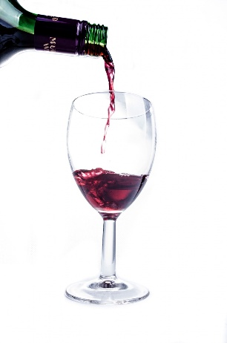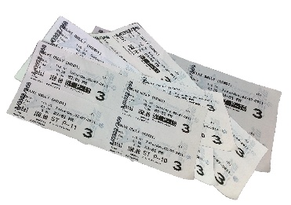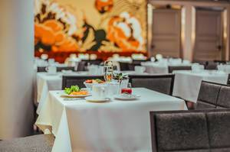
https://new.biddingowl.com/AORNBaltimore
Payments made through PayPal, Venmo or Zelle
All funds go to support our Scholarship and Education Initiatives

