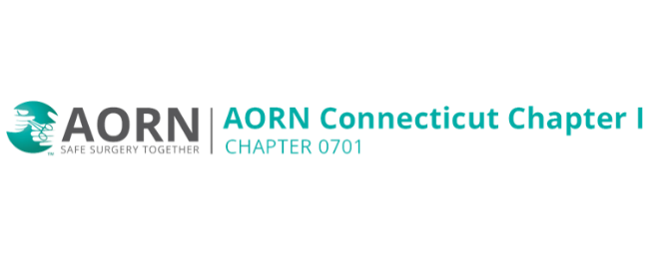
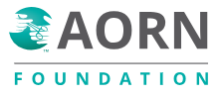
Virtual BINGO for the AORN Foundation
Thank you to the 22 chapters who co-sponsored a tremendously successful 2025 fundraiser for the AORN Foundation. We brought perioperative nurses and their family and friends together to learn about the AORN Foundation while having some fun. We raised $11,000 for the AORN Foundation to support perioperative nurses’ professional development.
I invite your chapter to join AORN CT 0701 as a co-sponsor in 2026!
Here are the details for 2026: Virtual event on Zoom open to any participants – nurses, family and friends of all ages.
Saturday, November 7th, 2026 at 7p EST
We will play 10 games of Bingo. Each winner (can be multiple per game) receives a $50 Amazon gift card via email. The evening will run about 2-2.5 hours, including short presentations about the AORN Foundation throughout the evening.
In summer 2026, The AORN Foundation will create a dedicated website for card purchasing by each participant. Each bingo card is a $10 donation to the AORN Foundation. You can purchase as many cards as you would like. And each card is played for every game.
In the week leading up to the event, each individual will receive a personalized email with their unique bingo card(s), directions and the virtual meeting Zoom link.
My ask and co-sponsoring chapter requirements:
Each co-sponsoring chapter will register on the designated AORN Foundation website with a $150 donation.
Promote, Promote, Promote - The more cards sold, the more participants and the greater the impact. Use the flyer on the AORN Foundation website to help spread the word.
Donors - Do you know a vendor, company, or individual that would like to make a donation or create a matching campaign as cards are sold? Please make an introduction through email to aornct0701@gmail.com.
Register Your Chapter Today!
Thank you for your support,
Leah Goldberg MSN, RN, CNOR
AORN CT 0701, Treasurer (Past President)
aornct0701@gmail.com

