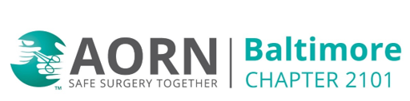
March 10, 2026 @6pm
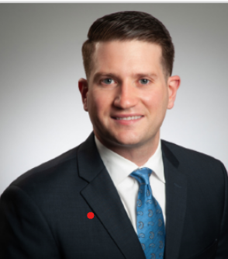
The Past, The Present and The Future of Hepatic Artery Infusion
Dr. Joshua Jolissaint, MD, MSc, Surgical Oncologist

In Person Meeting (Hybrid option) at University of Maryland Medical Center
22 South Greene St., Baltimore MD 21201
3rd Floor Round Room, W3L201
Cheese & crackers, Fruit, Desert provided

Zoom Meeting Option:

https://us02web.zoom.us/j/8253651972?pwd=OVZ3SkVmdUcrZ1NEczBrMVNYOEhuUT09
Meeting ID: 825 365 1972
Passcode: 0mbpVY
One tap mobile
+13017158592,,8253651972#,,,,*676091# US (Washington DC)

Dial by your location
+1 301 715 8592 US (Washington DC)
Meeting ID: 825 365 1972
Passcode: 676091
Find your local number: https://us02web.zoom.us/u/kbIEfjZcnO
1.0 Contact Hours pending

