2026 Acadiana Celebrates Nursing Awards
Nominations Now Open

Selection Criteria:
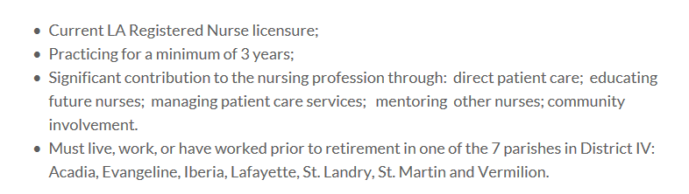
To nominate a Registered Nurse for this award, click on the QR code or link below:
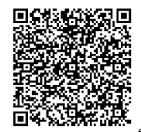
https://www.jotform.com/app/260204514236143

25 Registered Nurses will be honored at the Acadiana Celebrates Nursing Awards Banquet on Friday, May 8th at the Doubletree Hilton Ballroom
Deadline for nominations is Friday, February 20th at 6 pm

For further information, contact Elsie Meaux at 337-288-6798 or lsnadistrict4@gmail.com

