SAVE THE DATE!
The Diamond State Chapter of the AACN presents:
DSC Biannual Symposium 2026
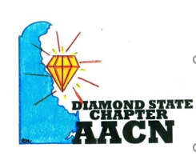
Advancing Acute and Critical Care Nursing Together
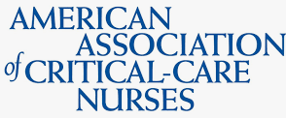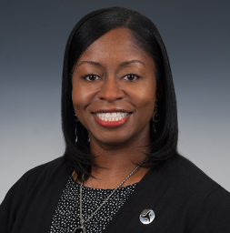
Featuring Keynote speaker:
Tonka Williams, DNP. MHA, RN, CMSRN, AACN President-Elect



When: Friday, September 25th, 2026
08:00 AM-3:30 PM
Registration will be available online prior to event, or in person morning of event.
Where: ChristianaCare Newark Campus
4755 Ogletown Stanton Rd
Newark, DE 19718

Cost: Pricing coming soon
Discount for students and Diamond State Chapter members

Hotel Information and call for abstracts coming soon!

For information about nursing continuing education, please use the link below:
Contact The Diamond State Chapter of AACN | The Diamond State Chapter of AACN | Nursing Network

This nursing continuing professional development activity was approved by the American Association of Critical Care Nurses, as accredited approver by the American Nurses Credentialing Center’s Commission on Accreditation.

Email ludmila_santiago-rotchford@bayhealth.org with questions
President Diamond State Chapter

