Virginia CNS Practice Modernization – SB 811

What the Bill Does
- Creates a structured, experience-based pathway to independent practice for prescribing CNSs.
- Aligns CNS regulation with existing Virginia NP and CNM models.

Why It Matters
- Improves access to care, especially in rural and underserved areas.
- Reduces administrative barriers without affecting safety.
- Maintains patient safety protections and regulatory oversight.
- Supports workforce stability and retention.

Key Changes at a Glance
- 1,000-hour supervised transition period.
- Supervision allowed by experienced prescribing CNSs or physicians.
- Independent practice authority after transition requirements.
- Scope of practice and oversight remain unchanged.

Bottom Line
- A modernization bill—not a scope expansion bill—providing a safe, structured pathway for experienced CNSs.

Constituent Support Letter for SB 811
You can find your legislator information here: https://whosmy.virginiageneralassembly.gov/
[Your Name]
[Your Address]
[City, VA ZIP]
[Email] | [Phone]
[Date]
The Honorable [Senator/Delegate Name]
[Address]
Dear [Senator/Delegate Last Name],
I am writing as a constituent from [locality] to express my strong support for SB 811, the Virginia CNS Practice Modernization Act. This legislation creates a structured, experience‑based pathway for prescribing Clinical Nurse Specialists (CNSs) to earn independent practice authority—mirroring the proven framework used for Nurse Practitioners and Certified Nurse Midwives.
SB 811 strengthens patient safety through a 1,000‑hour supervised transition, preserves consultation and referral requirements, and maintains full oversight by the Boards of Medicine and Nursing. It does not expand scope of practice. Instead, it modernizes outdated regulations that limit access to specialty care, particularly in rural and underserved communities.
I respectfully ask for your support of SB 811. Thank you for your service and consideration.
Sincerely,
[Your Name]

EMAIL template
Subject: Please Support SB 811 — Virginia CNS Practice Modernization Act
Dear [Senator/Delegate Last Name],
As your constituent, I’m asking you to support SB 811. This bill creates a structured, 1,000-hour supervised pathway for prescribing Clinical Nurse Specialists to earn independent practice—a model already proven safe for other APRNs. It maintains scope of practice, consultation requirements, and full Board oversight.
SB 811 improves access to specialty care, particularly in rural and underserved areas, while preserving patient safety.
Thank you for your consideration.
Sincerely,
[Your Name]

TEXT-BANK SCRIPT (Volunteer → Voter/Constituent)
INTRODUCTION (Volunteer):
Hi! My name is [Name] and I’m a volunteer with the Virginia Association of Clinical Nurse Specialists. We’re reaching out to ask for 30 seconds of your time to help improve access to care in Virginia.
WHY WE’RE TEXTING:
Many rural areas in Virginia struggle to maintain physician practice agreements, which means patients often lose access to CNS specialty care.
SB 811 fixes this by allowing CNS-to-CNS collaboration, helping keep services stable when physician availability changes
WHAT SB 811 DOES:
– Reduces costly, unnecessary contracts that don’t improve outcomes.
– Keeps all existing licensure, discipline, and oversight completely intact.
– Helps retain experienced CNSs in Virginia and aligns them with other APRNs.
– Strengthens mentorship and professional development pathways.
You can find your legislator information here: https://whosmy.virginiageneralassembly.gov/
THE ASK:
Would you be willing to contact your legislator today and ask them to support SB 811? A quick message or call makes a huge difference.
IF YES – PROVIDE NEXT STEPS:
Great! You can find your legislator here: https://whosmy.virginiageneralassembly.gov/
Just tell them you support SB 811 to improve access to care and strengthen the workforce.
IF NO/UNSURE:
No worries — thanks for your time! If you ever have questions about SB 811, I’m happy to help.

LinkedIn Version
Many Virginia communities lack consistent access to specialty care because physician practice agreements are often unavailable or unstable.
SB 811 offers a practical solution by allowing CNS-to-CNS collaboration, increasing workforce flexibility and stabilizing care delivery.
It also reduces unnecessary administrative contracts that raise costs without improving outcomes — while preserving full oversight by the Boards of Medicine and Nursing.
Finally, SB 811 improves retention by aligning CNS progression with other APRNs and supporting mentorship and professional development.
SB 811 is smart, safe modernization — not scope expansion.
I strongly support its passage.

SB 811 — Ultra-Short SMS Options (≤160 chars)
Option 1 (Access to Care) – 145 chars
Support SB 811! Rural areas lack physician agreements, and CNS-to-CNS collaboration keeps care going. Improve access without changing scope.

Option 2 (Efficiency & Cost) – 152 chars
Support SB 811! It removes costly, unnecessary contracts while keeping full Board oversight. Smart reform that keeps care safe.

Option 3 (Workforce Retention) – 149 chars
Support SB 811! It keeps experienced CNSs in Virginia and aligns them with other APRNs—helping stabilize our healthcare workforce.

Option 4 (All-in-One Micro-Message) – 158 chars
Support SB 811! Better access, fewer barriers, and keeps CNSs in VA. No scope expansion—just modernization that preserves safety.

Option 5 (Fastest Possible) – 109 chars
Support SB 811! Fix barriers, improve access, keep CNSs in VA—no scope change. Safe, needed modernization.

Mobile-Friendly Email Template for SB 811
(Optimized for short screens, minimal scrolling, and quick legislative reading)
Subject: Please Support SB 811 – Improve Access to Care in Virginia
Dear Senator/Delegate [Last Name],
I’m writing as your constituent to ask for your support of SB 811, the Virginia CNS Practice Modernization Act.
Many communities in Virginia—especially rural areas—struggle with access to specialty care. Physician practice agreements are often unavailable or unstable, which limits CNS ability to provide care where it’s needed most. SB 811 helps by allowing CNS-to-CNS collaboration, increasing flexibility and improving continuity of care.
This bill also makes our healthcare system more efficient. It removes unnecessary contracts that add cost without improving outcomes and reduces administrative burden on both clinicians and practices. Importantly, it keeps all existing licensure, discipline, and oversight fully intact.
SB 811 will also help retain experienced Clinical Nurse Specialists in Virginia by aligning CNS career progression with other APRNs. It supports mentorship and professional development—key for a stable healthcare workforce.
And to be clear: SB 811 does not expand scope of practice.
It simply modernizes outdated processes so that experienced CNSs can keep serving our communities safely and effectively.
Thank you for considering support for SB 811 and for your service to our district.
Sincerely,
[Your Name]
[Your City], Virginia

Instagram friendly picture
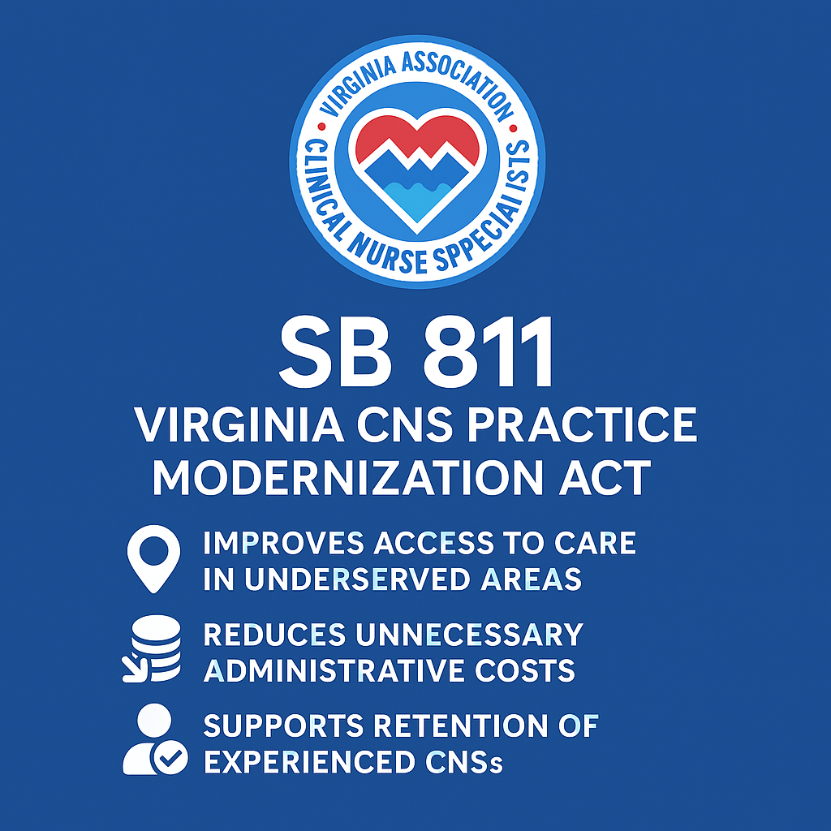
You can find your legislator information here: https://whosmy.virginiageneralassembly.gov/

