We invite all Mountain Area Perianesthesia Nurse members and those considering joining ASPAN to join us for our annual PeriAnesthesia Nurses Week Celebration
Tuesday February 3, 2026
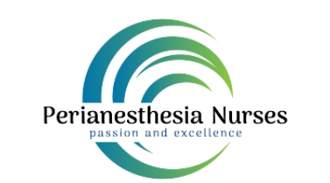
When: February 3, 2026
Where: Post 25 Kitchen & Lounge
2155 Hendersonville Road, Arden 28704
Time: 5:30 pm

MAPAN will provide door prize raffles for attendees. Meal, non-alcoholic beverage, and education will be provided by Abbott with an overview of Spinal Cord Stimulation Therapy. We are looking forward to a time of fellowship and collegiality with our PeriAnesthesia friends across WNC.

***Please RSVP to Jennifer White at Jennifer.white@unchealth.unc.edu by January 31, 2026
(only 25 seats available and members get 1st preference)

